

**Requirements Specification Document**

**SureLock Storage Management System**

**Golf Island Software**

**March 19th, 2019**

**List of Tables and Figures** 4

**Revision History** 5

1 Introduction 5

1.1 Purpose 5

1.2 Project Scope 5

1.3 Glossary of Terms 6

1.4 References 6

1.5 Overview 7

2 Overall Description 7

2.1 Product Perspective 7

2.2 Product Features 7

2.3 User Classes and Characteristics 8

2.4 Operating Environment 8

2.5 Design and Implementation Constraints 8

2.6 Assumptions and Dependencies 9

3 System Features 9

3.1 Storage Facility Information 9

3.1.1 Description and Priority 9

3.1.2 Functional Requirements 10

3.2 Storage Unit Information 10

3.2.1 Description and Priority 10

3.2.2 Functional Requirements 10

3.3 System Searching Feature 11

3.3.1 Description and Priority 11

3.3.2 Functional Requirements 12

3.4 Account Management Feature 12

3.4.1 Description and Priority 12

3.4.2 Functional Requirements 12

4 External Interface Requirements 12

4.1 Software Interfaces 12

5 Other Non-Functional Requirements 13

5.1 Performance Requirements 13

5.2 Security Requirements 13

5.3 Software Quality Attributes 13

6 Other Requirements 14

7 Models and Diagrams 15

7.1 Data Modelling 15

7.1.1 Entity Relationship Diagram 15

7.1.2 Data Dictionary 16

7.2 Data Flow Diagrams 19

7.3 Use Cases and Sequence Diagrams 21

7.3.1 Account Management Use Cases 21

7.3.2 Storage Facility Information Use Cases 29

7.3.3 Storage Unit Information Use Cases 48

7.3.4 System Searching Feature Use Cases 68

7.4 Use Case Model 96

96

## 

## **List of Tables and Figures**

Table 1: Data Dictionary 17  
  
Figure 1: ER Diagram 15  
Figure 2: Level 0 and Level 1 Data Flow Diagrams 19  
Figure 3: Level 2 Data Flow Diagrams 20  
Figure 4: UCAM-01 Sequence Diagram and UI Models 21  
Figure 5: UCAM-02 Sequence Diagram and UI Models 25  
Figure 6: UCAM-03 Sequence Diagram and UI Models 26  
Figure 7: UCSFI-01 Sequence Diagram and UI Models 30  
Figure 8: UCSFI-02 Sequence Diagram and UI Models 31  
Figure 9: UCSFI-03 Sequence Diagram and UI Models 37  
Figure 10: UCSFI-04 Sequence Diagram and UI Models 38  
Figure 11: UCSFI-05 Sequence Diagram and UI Models 48  
Figure 12: UCSUI-01 Sequence Diagram and UI Models 49  
Figure 13: UCSUI-02 Sequence Diagram and UI Models 50  
Figure 14: UCSUI-03 Sequence Diagram and UI Models 51  
Figure 15: UCSUI-04 Sequence Diagram and UI Models 56  
Figure 16: UCSUI-05 Sequence Diagram and UI Models 57  
Figure 17: UCSUI-06 Sequence Diagram and UI Models 64  
Figure 18: UCSSF-01 Sequence Diagram and UI Models 69  
Figure 19: UCSSF-02 Sequence Diagram and UI Models 80  
Figure 20: UCSSF-03 Sequence Diagram and UI Models 85  
Figure 21: UCSSF-04 Sequence Diagram and UI Models 90  
Figure 22: Use Case Model 96

## 

## **Revision History**

|  |  |  |  |
| --- | --- | --- | --- |
| Name | Date | Reason for Changes | Version |
| Entire Team (Andy Smith, Eric Wiebe, Jared Larter, Jeremy Megyesi, Mona Soleimanieh, Rhett Devlin, Ryan Russell, Subah Mehrotra) | Feb. 28th, 2019 | Revisions from annotated RD1.1 and instructor feedback | 0.8 |
| Entire Team | Mar. 12th, 2019 | Creation of section 7 and addition of models | 0.9 |
| Entire Team | Mar. 19th, 2019 | Revisions of RSD 0.9 from client meeting feedback | 1.0 |

# 1 Introduction

## 1.1 Purpose

This document details the requirements for the SureLock Storage Management System Version 1.0. SureLock’s current system makes it difficult to track client information such as payment status and unit location. SureLock Storage seeks to improve company organization and management by making client and storage unit information easier to access, read, and parse. This document pertains to the entirety of the storage management system.

## 1.2 Project Scope

SureLock Storage’s goal is to increase organization by implementing a software system to store and retrieve storage unit information. The information will include client full name, currently rented storage units, current balance and fees, as well as storage unit details, including dimensions, rented status, and condition, and will have searchable components. This information will enhance SureLock’s organization by being readily updatable and accessible.

SureLock Storage hopes to increase company management and security by controlling who can edit and view client information. The storage management system will include Administrator and Staff Member accounts. This will limit the access of the Staff Members to ensure that client information is secure.

The storage management system will employ four main features: a storage facility information feature, a storage unit information feature, a system searching feature, and an account management feature. The four features will provide users with context of where storage units are located, the details of each unit, and who is renting the unit, in addition to making relevant information easily accessible and searchable.

## 1.3 Glossary of Terms

**[Storage] Units:** A locked room used to store the client’s personal belongings. The floor space ranges from 4ft x 5ft to 10ft x 20ft.

**[Storage] Facility:** The property where the storage units are located. Currently, SureLock operates one facility with 200-225 units.

**IT Team:** A team of individuals trained to manage and troubleshoot the software system at a higher level than regular Staff Members. Each member of the IT Team has an Administrator account.

**Client:** The customer renting the storage unit from SureLock Storage.

**Client Information:** The full name, email, phone number, transaction documents and current balance unique to a specific client on a specific unit.

**Account:** An account is a set of credentials consisting of a unique username and a password. An account is required to access the storage management system. Each employee of SureLock storage will have a unique account. Multiple accounts of each type can be created.

**Staff Member:** The account type for an employee who will be using the software system. The Staff Member accounts have limited access to client information.

**Administrator:** The account type for a manager or member of the IT Team of SureLock Storage who has access to all system features and client information.

**Transaction Documents:** Documents such as invoices and receipts that are generated manually or automatically as the result of a storage unit payment or owed amount.

## 1.4 References

[1] SureLock Storage Client Group 1. (2019, Jan. 22). *SureLock Storage.* [Webpage]. Available: <https://ansh-projects.github.io/SENG321-websites/client.html#slogan>

[2] SureLock Storage Client Group 1. (2019, Jan.). *Storage Management System Development Request for Proposal.* SureLock Storage. Victoria, BC. [Online]. Available: <https://ansh-projects.github.io/SENG321-websites/assets/group1_RFP.pdf> [Accessed: Jan. 30, 2019].

[3] Microsoft. *Microsoft Excel* [Online]. Redmond, WA: Microsoft, 2018. Available: <https://products.office.com/en-ca/excel>

[4] Officer of the Information and Privacy Commissioner of Alberta. *PIPA* [Online]. Available: <https://www.oipc.ab.ca/legislation/pipa.aspx> [Accessed: Feb, 2019].

## 1.5 Overview

This requirements specification document (RSD) contains 7 sections and a table of contents. The RSD begins by realizing the necessity of a software solution for SureLock Storage. Section 2 describes the overall description of the system that needs to be produced, how it will be used, who will use it, and the design constraints. Section 3 details the features and functional requirements of the system. Section 4 describes how the system is to interface with SureLock Storage’s current systems. Sections 5 and 6 describe the non-functional requirements of the system including performance, efficiency, security, and legal requirements. Section 7 contains the models of the system including data flow diagrams, entity relationship diagrams, and the use case model, as well as the use cases with UI models.

# 

# 2 Overall Description

## 2.1 Product Perspective

The storage management system currently being developed by Golf Island Software is a replacement for SureLock Storage’s current unit management system. Currently, SureLock Storage gathers client information through email and uses Microsoft Excel to keep track of data such as method of payment, transaction history, balance, and unit cost. This new software system will assist SureLock Storage in its goals to improve company organization and management. The usage of this system will be exclusively internal to SureLock Storage. Administrators will have full access to the system, while Staff Members will have restricted access.

## 2.2 Product Features

The storage management system will include four main features: the storage facility information feature, the storage unit information feature, the system searching feature, and the account management feature. The storage facility information features a map of the storage units in the facility. The user will be able to access a unit’s information by selecting the unit from the facility map. The storage unit information will include unit details such as the client renting the unit, unit dimensions, and unit cost. Client information will also be viewable from the storage unit information interface and includes full name, contact information, and current balance. Storage unit information and client information will be editable by Administrators. The searching feature will provide each Staff Member and Administrator with the ability to search through the storage units by unit number, client’s full name, client’s phone number, and client’s email. Lastly, the account management feature ensures each Staff Member and Administrator have unique username and password protected accounts.

## 2.3 User Classes and Characteristics

The two intended user groups for this system are the Administrators and Staff Members at SureLock Storage. The system will require each user to login with a unique username and a password.

The Administrator account is the highest-level account for the storage management system. An Administrator will have the ability to add, remove, and edit unit and client information. Additionally, an Administrator will be able to add new storage units to the system.

The Staff Member account will be restricted to accessing unit specific information (such as unit availability) and basic client information (full name, email, and phone number). Staff Members will not be able to access any sensitive client information (transaction documents and current balance). Moreover, Staff Members will not be able to add or edit unit information, but they will be able to add and edit annotations on unit information.

Stakeholders of the system consist of the Administrators and Staff Members of SureLock Storage.

## 2.4 Operating Environment

The new software system is to be run on the desktop computers at the SureLock Storage office area. The current operating system (OS) used on SureLock’s office computers is Windows 7, so the software system must support Windows 7 and any Windows OS later than Windows 7 to account for any new office computers or OS upgrades on current office computers at SureLock Storage.

The current system consists of recording data on a whiteboard and in Microsoft Excel spreadsheets [3].

## 2.5 Design and Implementation Constraints

*Security*  
The new system must be secure; the new system must be accessible to management personnel using an Administrator account specific to each individual, with each account having a corresponding username and password. Each Staff Member account must have access to the new system with their own username and password (specific to each individual). Each account is created and assigned by an Administrator. The new system must not be accessible by any external third parties or clients. A username and password are required to provide secure access.

*System Access*Each Administrator must have full access to updating and editing client information on the new system. Each Staff Member must be able to view information relating to storage unit availability and add necessary annotations but must not have access to any sensitive client information such as payment methods and transaction documents.

*Transaction Documents*The new system must retain all payment and transaction information dating two years prior.

*Expansion*The graphical interface of the new system must include a way to add storage units dynamically to support facility expansion. This expansion includes the addition of units to the current facility. The system must handle an increased number of devices and simultaneous users to compensate for any facility expansion.

*Budget*The total cost of the project (development and implementation of the new system) must be within the given budget of $50,000.

## 2.6 Assumptions and Dependencies

* Any future development will take place within the province of Alberta; there are currently no plans to expand outside of Alberta.
* Any new computers obtained for office use will have a modern Windows operating system (Windows 7 or later).
* While the system is to record transactions, the system is not required to interact with payments directly. Rather, a transaction may occur separately, and any pertinent documents will be uploaded and linked to the corresponding unit by an Administrator.
* A Staff Member is not responsible for adding a new client or updating client information. That is, only an Administrator will add or update client information.

# 3 System Features

This section details integral system features that will be implemented within a new system for SureLock Storage. The priority for each feature is noted in bold following the feature’s description. Each system feature has one or more functional requirements.

## 3.1 Storage Facility Information

### 3.1.1 Description and Priority

Viewing information about the storage facility is the foundation of the system. The location of each unit in the facility will be viewable in the facility map.

**Priority: High**

### 3.1.2 Functional Requirements

REQ-SFI-01: Each Staff Member and Administrator must be able to view a map of the storage facility with the location of each unit.

REQ-SFI-02: Each storage unit on the map must have a link to that unit’s information.

REQ-SFI-03: Each storage unit’s availability must be identifiable and displayed.

REQ-SFI-04: Each Administrator must be able to assign a client to an available unit.

* If the unit already currently has an assigned client, the Administrator will not be able to assign an additional client to the unit.

REQ-SFI-05: Each Administrator must be able to remove a client from a unit, which will set the unit to available.

REQ-SFI-06: Each Administrator must be able to add additional units, which will automatically update the map mentioned in REQ-SFI-01.

## 3.2 Storage Unit Information

### 3.2.1 Description and Priority

Viewing and editing storage unit information is essential to the system. Viewing storage unit information consists of viewing the information fields of a unit consisting of information about the specific unit and the client renting the storage unit from the facility. Editing storage unit information consists of editing the information fields.

**Priority: High**

### 3.2.2 Functional Requirements

REQ-SUI-01: Each Administrator must be able to view unit information.

* The information must include:
  + Unit Number
  + Unit Dimensions
  + Unit Availability
  + Unit Rent Cost
  + Unit Current Balance
  + Client’s Full Name
* The information may include:
  + Client’s Email
  + Client’s Phone Number
  + Client’s Payment Methods
  + Transaction Documents
  + Last Payment Date
  + Annotations

REQ-SUI-02: Each Staff Member must be able to view restricted unit information.

* The information must include:
  + Unit Number
  + Unit Dimensions
  + Unit Availability
  + Unit Rent Cost
  + Client’s Full Name
* The information may include:
  + Client’s Email
  + Client’s Phone Number
  + Annotations

REQ-SUI-03: Each Administrator must be able to edit unit information.

* The information must include:
  + Unit Dimensions
  + Unit Availability
  + Unit Rent Cost
  + Unit Current Balance
  + Client’s Full Name
* The information may include:
  + Client’s Email
  + Client’s Phone Number
  + Client’s Payment Methods
  + Transaction Documents
  + Last Payment Date

REQ-SUI-04: Each Staff Member and Administrator must be able to add and edit annotations on the unit information.

REQ-SUI-05: Each Administrator must be able to upload and delete transaction documents associated with specific units.

## 3.3 System Searching Feature

### 3.3.1 Description and Priority

Searching for storage unit, transaction documents, and client information is useful for users to quickly find relevant documents and information when interacting with the system.

**Priority: High**

### 3.3.2 Functional Requirements

REQ-SSF-01: Each Staff Member and Administrator must be able to search for a unit by the following information:

* Client’s Full Name
* Client’s Email
* Client’s Phone Number
* Unit Number
* Unit Availability

REQ-SSF-02: Each Administrator must be able to search the archived transaction documents by the following information:

* File Name
* Associated Unit Number
* Associated Client’s Full Name

## 3.4 Account Management Feature

### 3.4.1 Description and Priority

Account management is crucial to usage of the overall system. The account management system consists of logging in and out of the system, as well as creating new accounts for Administrators and Staff Members.

**Priority: High**

### 3.4.2 Functional Requirements

REQ-AMF-01: Each Staff Member and Administrator must enter a unique username and password to sign into their personal account.

REQ-AMF-02: Each Staff Member and Administrator must be able to log out of their account.

REQ-AMF-03: Each Administrator must be able to create an Administrator account and a Staff Member account with a unique username and password.

* If a username is already in use, it cannot be used to create a new account.

# 4 External Interface Requirements

## 4.1 Software Interfaces

REQ-EI-01: Each Administrator must be able to import and export Microsoft Excel documents.

REQ-EI-02: Each Staff Member and Administrator must be able to operate the system in Microsoft Windows 7, 8, 8.1, or 10.

# 5 Other Non-Functional Requirements

## 5.1 Performance Requirements

REQ-NF-01: Searching for a storage unit in the system should take fewer than 5 seconds.

REQ-NF-02: Opening the system should take no more than 1 minute.

REQ-NF-03: Processing new clients or storage units in the system should take within 5 seconds.

REQ-NF-04: Each map must support the display of at least 500 storage units.

REQ-NF-05: At least five users must be able to simultaneously use the system.

## 5.2 Security Requirements

REQ-NF-06: Each Staff Member and Administrator must enter a unique username and password to sign into their personal account.

REQ-NF-07: Passwords must not be viewable by default.

REQ-NF-08: Each Administrator account must not be restricted from any information in the system.

REQ-NF-09: Unit information pertaining to a specific client must be automatically deleted 2 years after the client pays off debts and ceases renting units.

REQ-NF-10: Each Administrator with an existing account must be able to create a new Staff Member or Administrator account.

REQ-NF-11: Each Administrator must have access to a list of each Staff Member and Administrator Account password.

## 5.3 Software Quality Attributes

REQ-NF-11: The system should be manageable and maintainable by the IT team.

# 6 Other Requirements

REQ-NF-12: The client information within the storage unit must be compliant with Alberta’s Personal Information Protection Act [4].

# 7 Models and Diagrams

## 7.1 Data Modelling

### 7.1.1 Entity Relationship Diagram

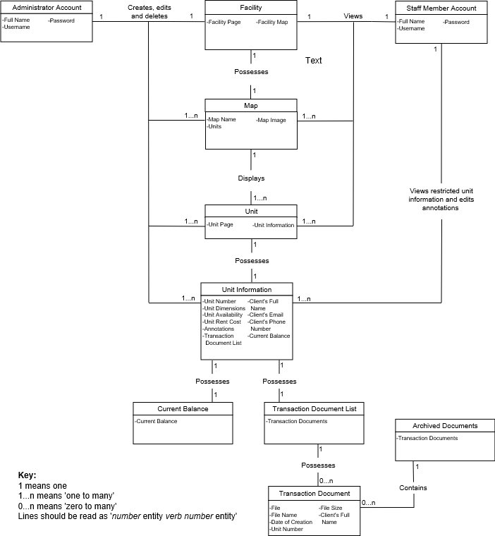

*Figure 1. Entity Relation Diagram*

### 7.1.2 Data Dictionary

|  |  |  |
| --- | --- | --- |
| **Entity** | **Field** | **Field Type** |
| Administrator Account |  | |
|  | Full Name | *String* |
| Username | *String* |
| Password | *String* |
| Staff Member Account |  | |
|  | Full Name | *String* |
| Username | *String* |
| Password | *String* |
| Facility |  | |
|  | Facility Page | *Page* |
| Facility Map | *Map* |
| Map |  | |
|  | Map Name | *String* |
| Map Image | *Image file* |
| Units | *Unit* |
| Unit |  | |
|  | Unit Page | *Page* |
| Unit Information | *Unit Information* |
| Unit Information |  | |
|  | Unit Number | *Int* |
| Unit Dimensions | *Int array* |
| Unit Availability | *String* |
| Unit Rent Cost | *String* |
| Client’s Full Name | *String* |
| Client’s Email | *String* |
| Client’s Phone Number | *String* |
| Annotations | *String* |
| Payment Methods | *String* |
| Current balance | *Current balance* |
| Transaction Document List | *Transaction Document List* |
| Current balance |  | |
|  | Current balance | *Float* |
| Account Updates | *String array* |
| Transaction Document List |  | |
|  | Transaction Documents | *Transaction Document* |
| Transaction Document |  | |
|  | File | *File (.*)* |
| File Name | *String* |
| Date of Creation | *Int* |
| File Size | *Int* |
| Client’s Full Name | *String* |
| Unit Number | *Int* |
| Archived Documents |  |  |
|  | Transaction Document List | *Transaction Document List* |

*Table 1. Data Dictionary*

## 

## 7.2 Data Flow Diagrams

Figure 2 (see below) shows the context diagram (DFD 0) and the Level 1 Data Flow Diagram (DFD 1). The context diagram shows data-transfer between the entities (Administrator and Staff Member) and the Storage Management System, while the DFD 1 shows a breakdown of the four basic processes (with respective data flow) contained within the Storage Management System.

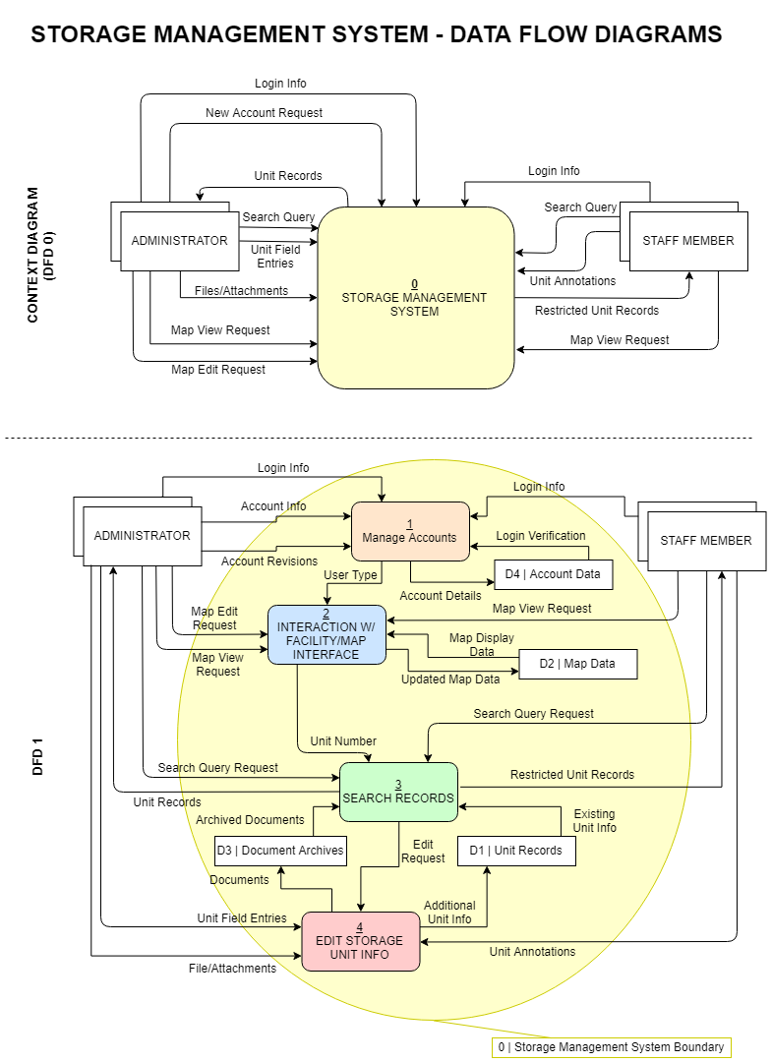

*Figure 2: Level 0 and Level 1 Data Flow Diagrams*

The Level 2 Data Flow Diagram (DFD 2) shows further breakdown of each of the four basic processes contained within the Storage Management System (see Figure 3). The colours of each of the four basic processes seen in DFD 1 (Figure 2) correspond to the background colour that groups the subprocesses (ie. subprocesses 1.1, 1.2, and 1.3 are grouped by an orange background, and therefore correspond to the ‘Manage Accounts’ process seen in the DFD 1). The DFD 2 is split up into multiple sections; each section contains the subprocesses (grouped based on the main processes) and are labeled ‘DFD 2.[main process #]’. Data flow between DFD 2 sections is also shown in Figure 3. All content in Figure 3 is contained within the Storage Management System Boundary.

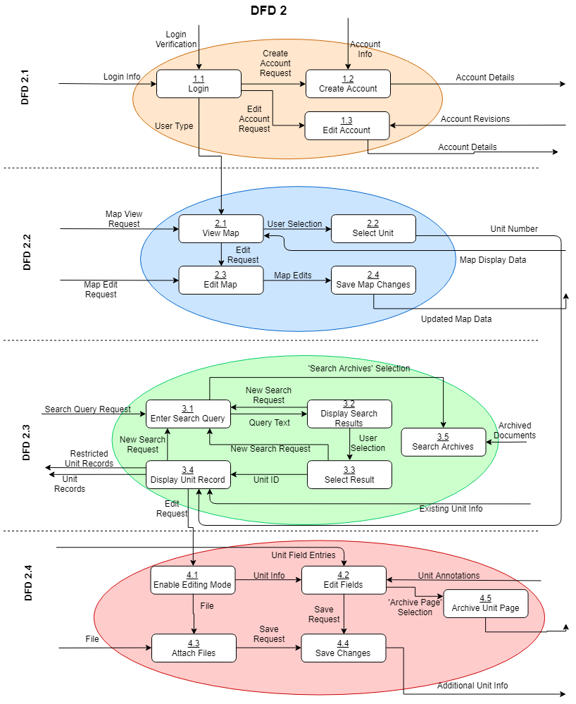

*Figure 3: Level 2 Data Flow Diagrams*

## 7.3 Use Cases and Sequence Diagrams

### 7.3.1 Account Management Use Cases

**Use Case UCAM-01: Logging In**

Actors: Administrators and staff members

Precondition: None

Steps:

1. The user enters their username and password
2. The user submits their entered username and password

Success Condition: The user will be logged into the system and have security access based on their account type

Exception: 2a) The username and password are not associated with an account. User is returned to the login screen. The use case ends.

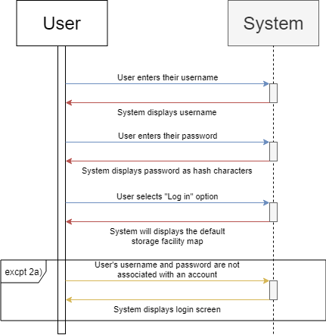

*Figure 4: UCAM-01 Sequence Diagram*

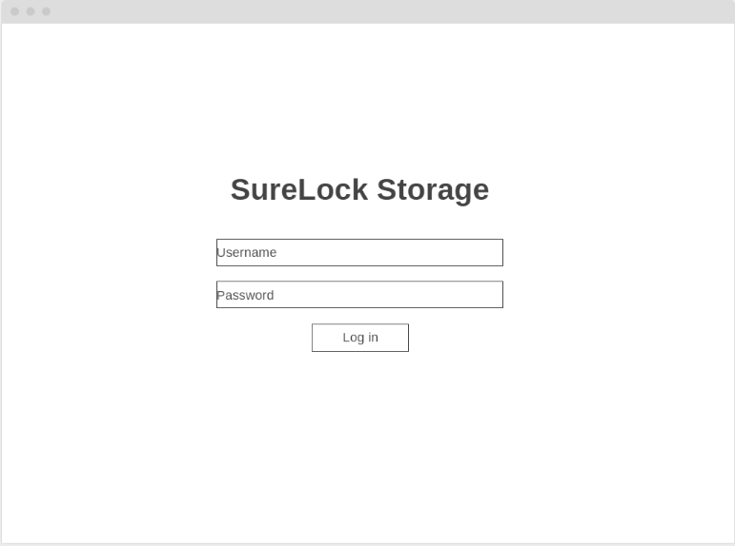

*Figure 4.1: UCAM-01 UI Screen 1 – Login Screen*

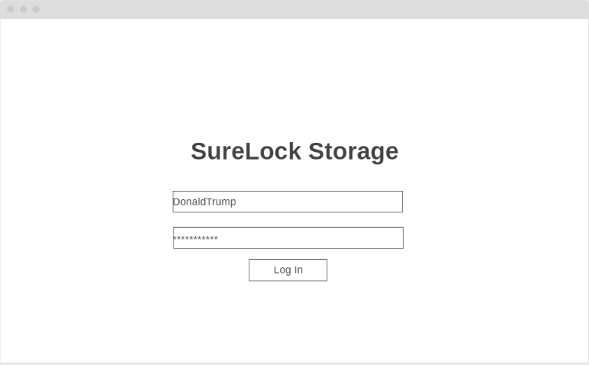

*Figure 4.2: UCAM-01 UI Screen 2 – Login Screen with Credentials*

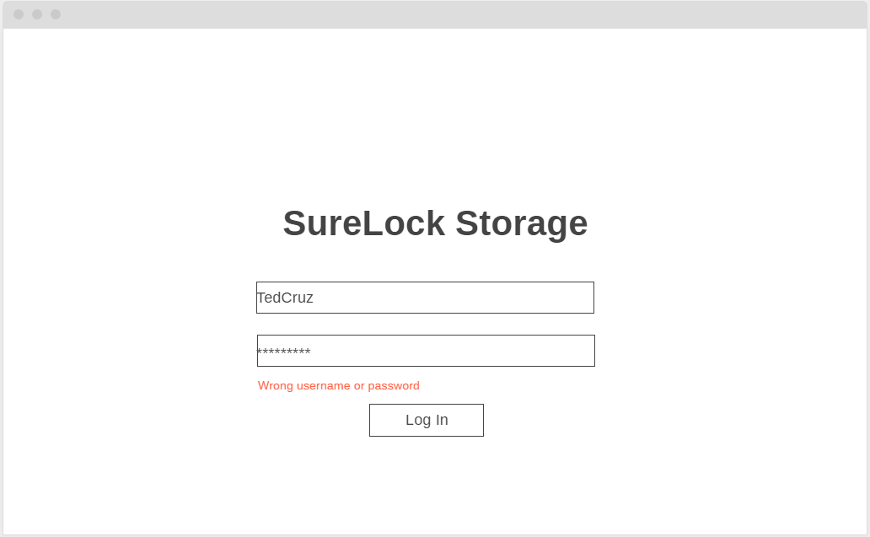

*Figure 4.3: UCAM-01 Exception 2a: UI Screen 1 – Login Screen with Wrong Credentials*

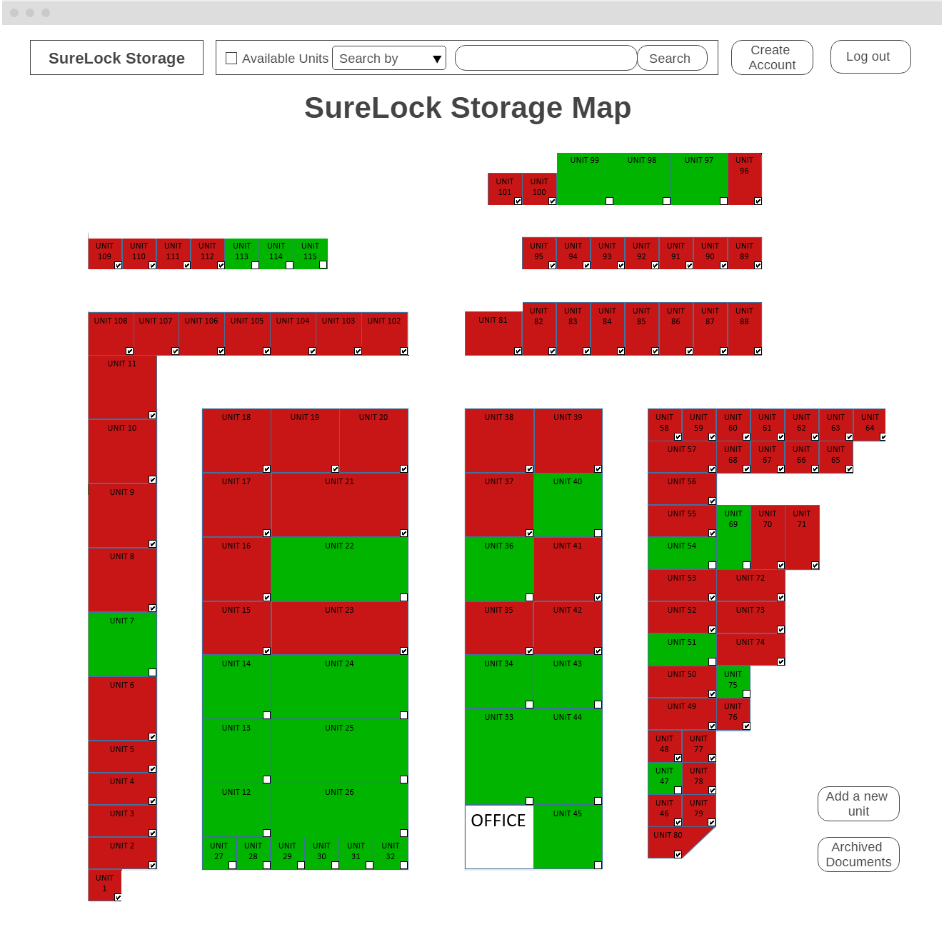

*Figure 4.4: UCAM-01 UI Screen 3 – Map Screen*

An Administrator or a Staff Member will be able to click the “Log In” button after entering their username and password in order to log in to the system. They will be directed to the facility map page and have security access based on their account type.

**Use Case UCAM-02: Logging Out**

Actors: Administrators and staff members

Precondition: The user is logged into the system under a valid account

Steps:

1. The user selects to log out
2. The user confirms their selection to log out

Success Condition: The user will be logged out of the system

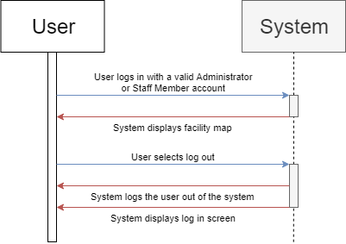

*Figure 5: UCAM-02 Sequence Diagram*

**Use Case UCAM-03: Creating an Account**

Actors: Administrators

Precondition: The user is logged into the system under an Administrator account

Steps:

1. The user selects to create account
2. The user enters username, password, and full name for the new account
3. The user selects the account type
4. The user submits entered information

Success Condition: The account will be created with the entered information and selected account type.

Exception: 4a) The user cancels before submitting the information. The account is not created. The use case ends.

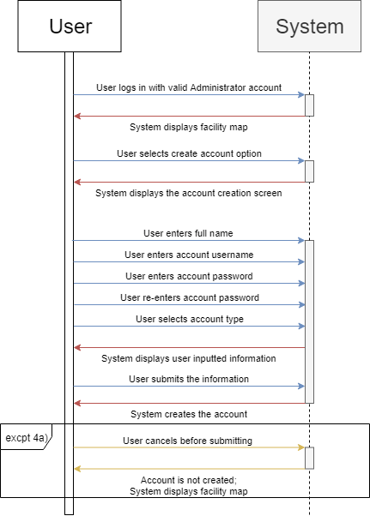

*Figure 6: UCAM-03 Sequence Diagram*

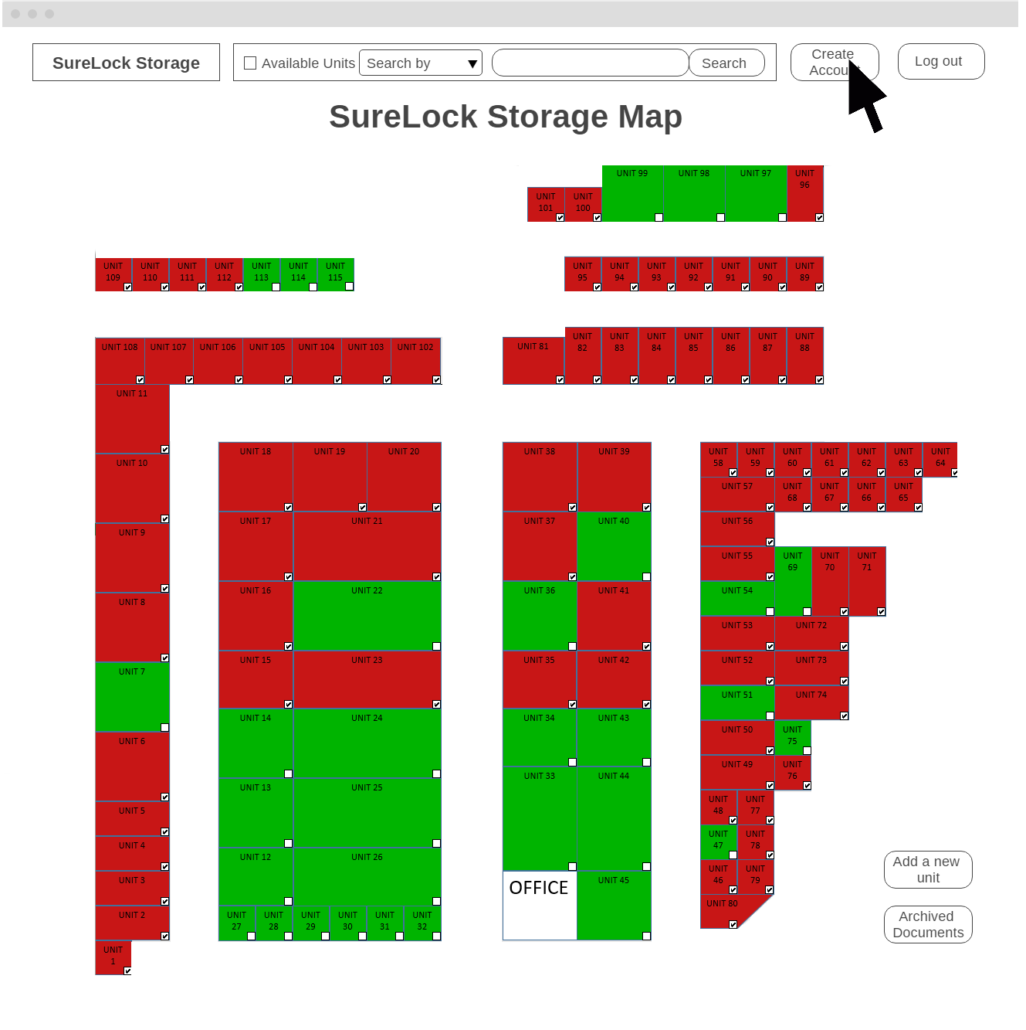

*Figure 6.1: UCAM-03 UI Screen 1 – Map Screen*

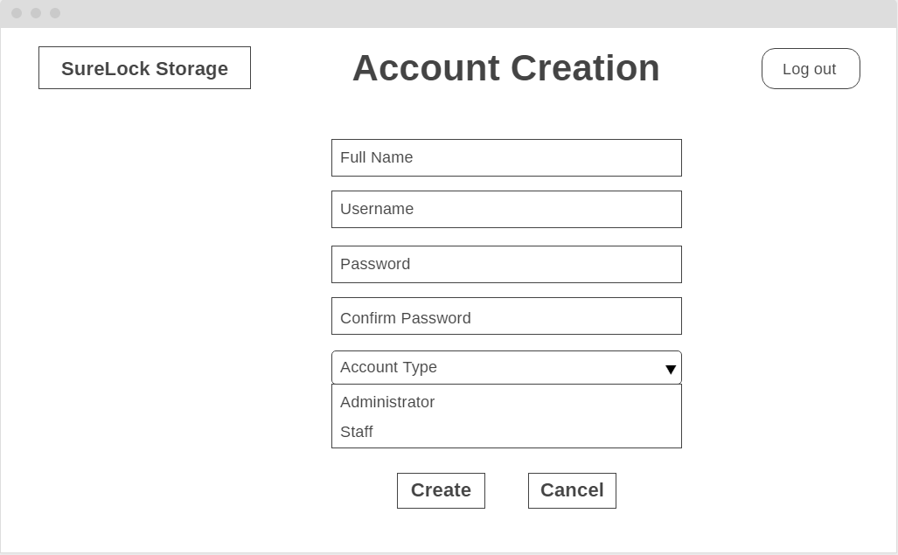

*Figure 6.2: UCAM-03 UI Screen 2 – Account Creation Screen*

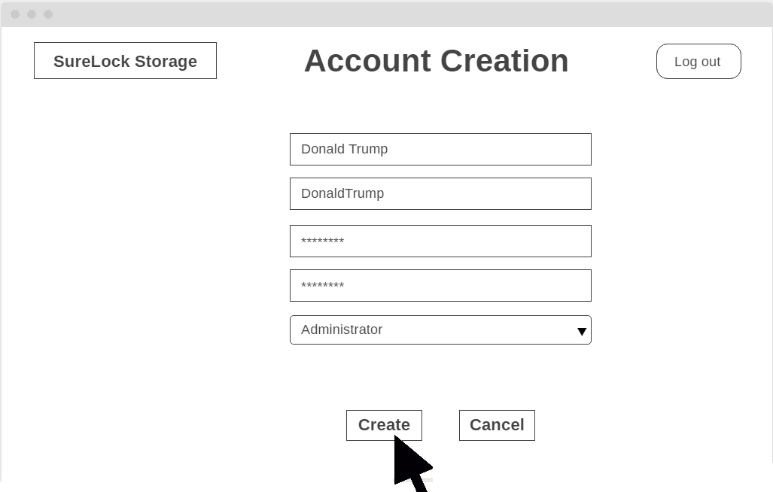

*Figure 6.3: UCAM-03 UI Screen 3 – Administrator Account Creation Screen*

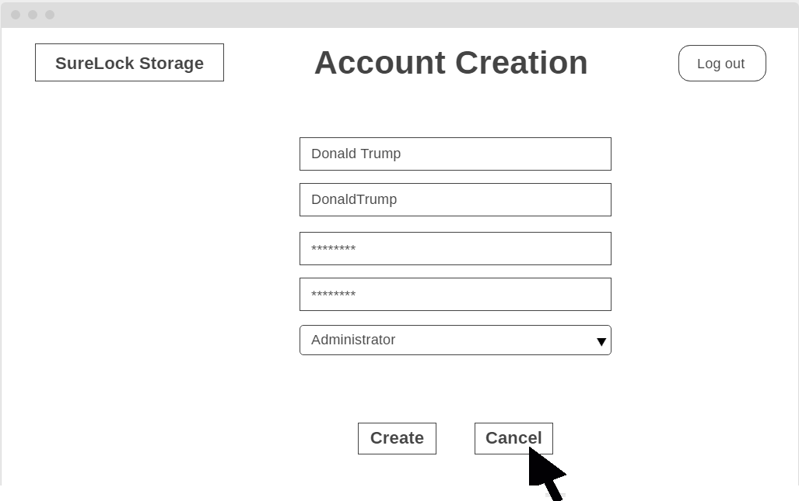

*Figure 6.4: UCAM-03 Exception 4a: UI Screen 1 – Cancel Administrator Account Creation Screen*

The Administrator clicks “Create Account”. After entering a full name, username, password, and confirming the password, the Administrator chooses “Administrator” from the dropdown box in order to create an Administrator account. By clicking “Create”, the Administrator submits the information the Administrator typed and create an account.

### 7.3.2 Storage Facility Information Use Cases

**Use Case UCSFI-01: Viewing the Storage Facility Map**

Actors: Administrators and Staff Members

Precondition: A user has logged in to the system under a valid account

Steps:

1. The user views the map

Success Condition: The map is displayed to the user

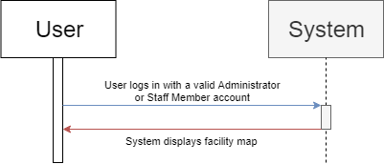

*Figure 7: UCSFI-01 Sequence Diagram*

**Use Case UCSFI-02: Assigning a unit to a client**

Actors: Administrators

Precondition: A user has logged in to the system under an Administrator account

Steps:

1. The user selects an available unit from the map
2. The user inputs a client full name, client phone number, payment amount, and payment method
3. The user selects to save the inputted information

Success Condition: Unit information will be updated to display the inputted information and show that the unit’s availability is now ‘not available’

Exception: 3a) The user cancels their unit annotation before submitting. The annotation is not saved to the unit information. The use case ends.

Alternate Path: 2a) The user does not input payment amount and payment method

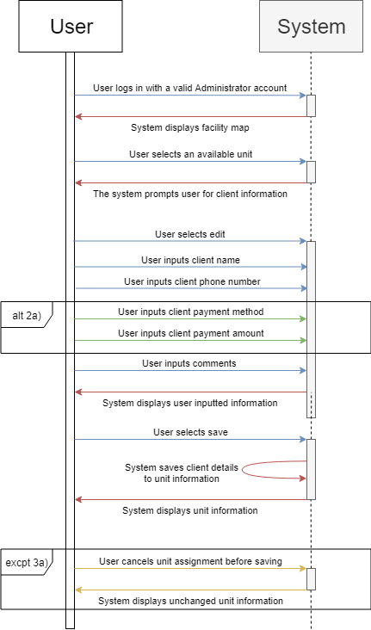

*Figure 8: UCSFI-02 Sequence Diagram*

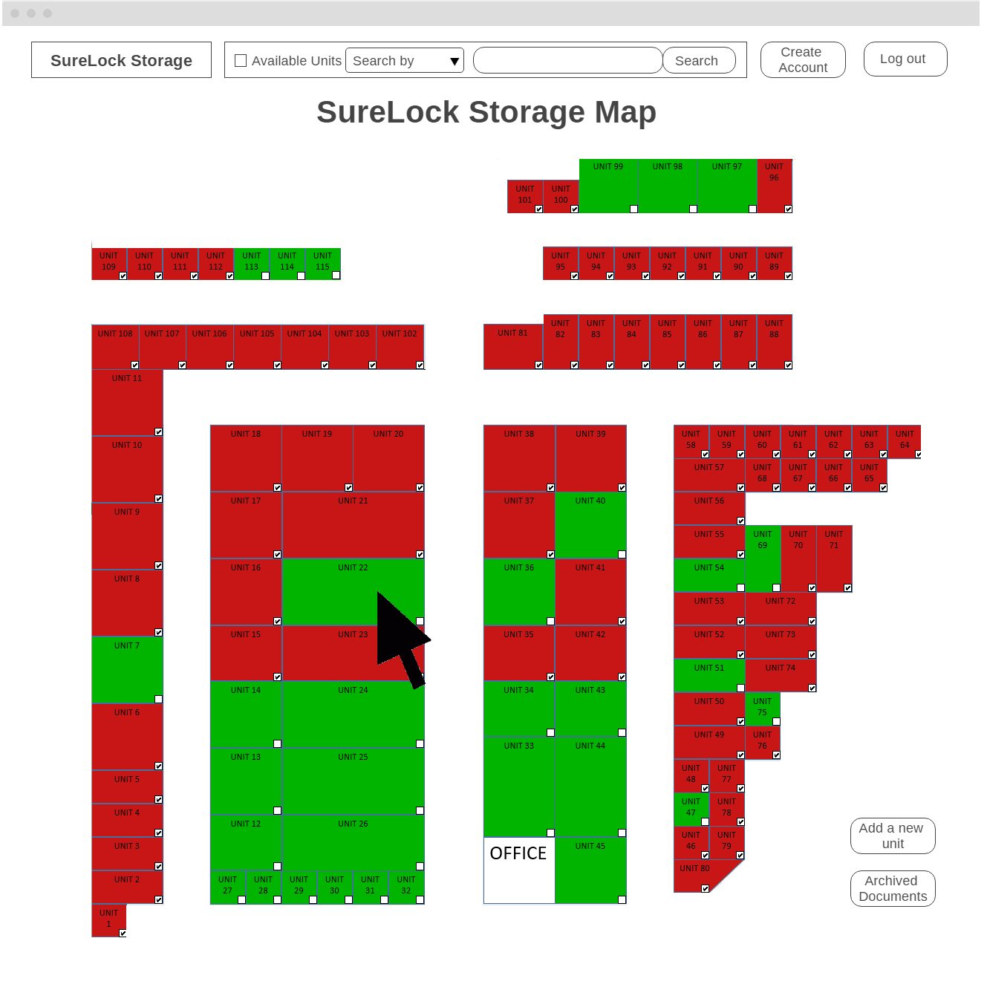

*Figure 8.1: UCSFI-02 UI Screen 1 – Map Screen*

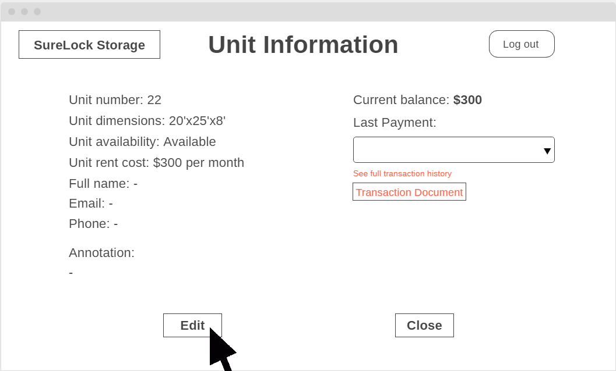

*Figure 8.2: UCSFI-02 UI Screen 2 – Unit Information Screen*

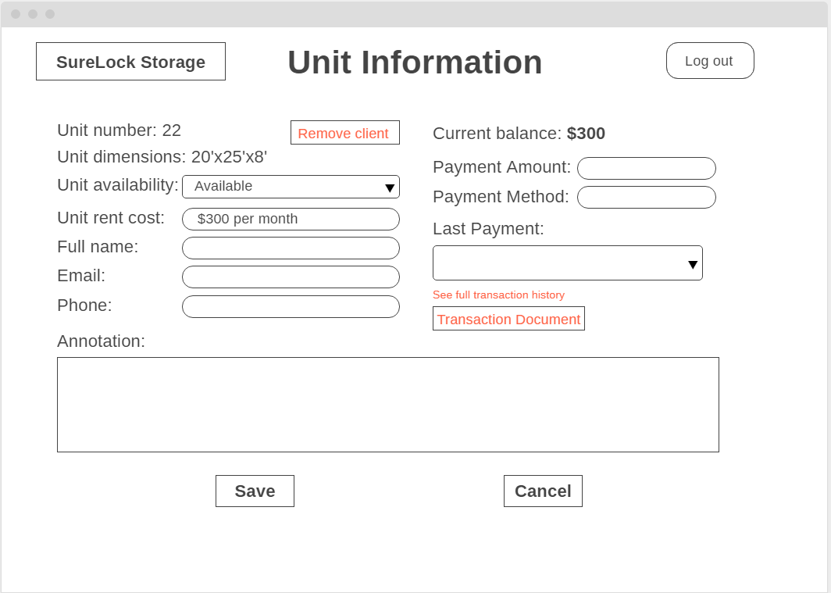

*Figure 8.3: UCSFI-02 UI Screen 3 – Unit Information Editing Screen*

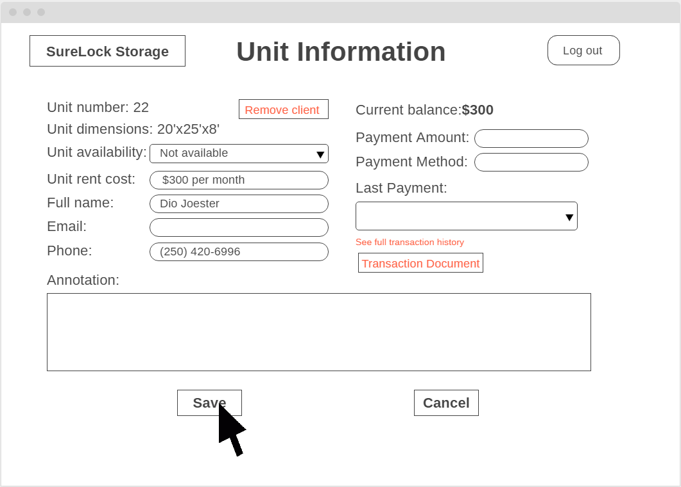

*Figure 8.4: UCSFI-02 Alternate 2a: UI Screen 1 – Unit Information Editing Screen Without Payment Method and Payment Amount*

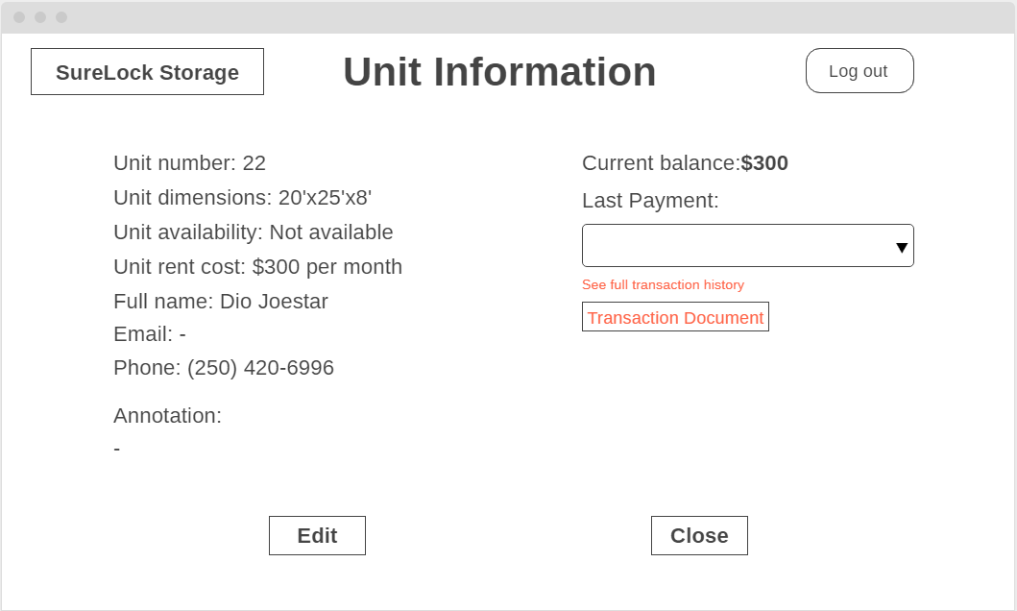

*Figure 8.5: UCSFI-02 Alternate 2a: UI Screen 2 – Unit Information Screen Without Payment Method and Payment Amount*

**

*Figure 8.6: UCSFI-02 UI Screen 4 – Unit Information Editing Screen*

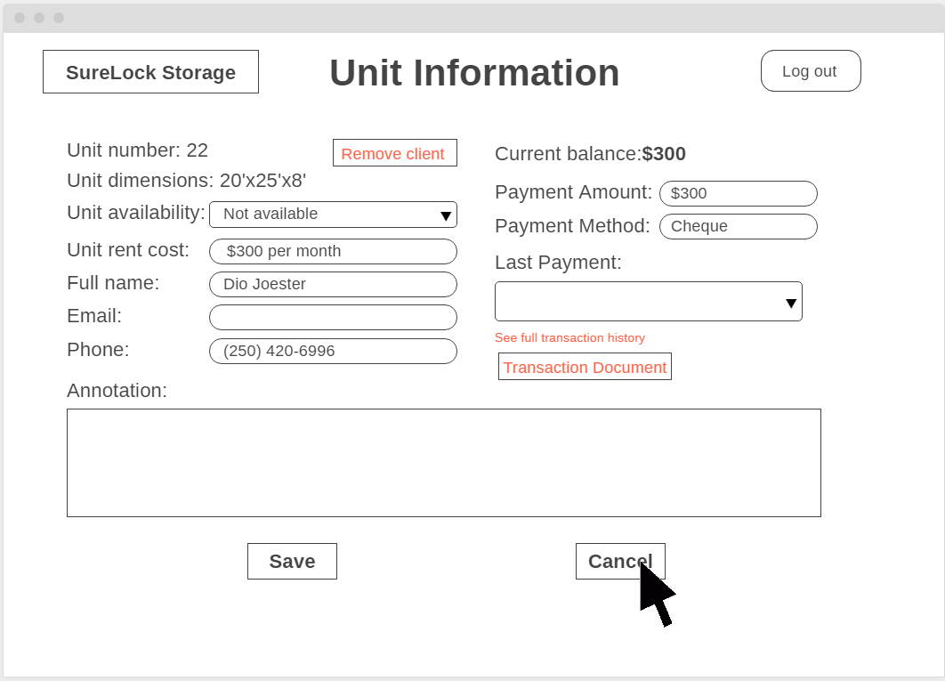

*Figure 8.7: UCSFI-02 Exception 3a: UI Screen 1 – Cancel Unit Information Editing Screen*

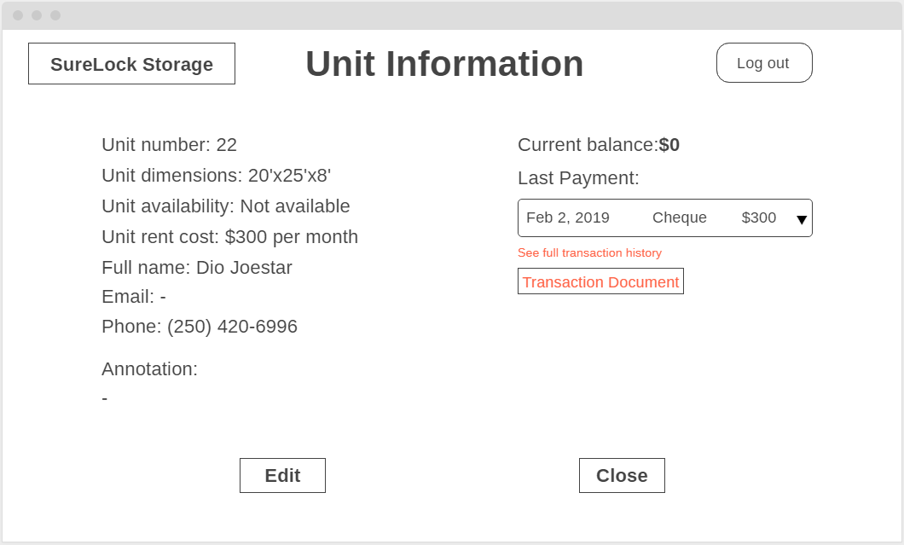

*Figure 8.8: UCSFI-02 UI Screen 5 – Unit Information Screen*

The Administrator selects unit 22 from the facility map. The Administrator enters the view mode of the unit information. The Administrator selects “Edit” button to enter the edit mode of the unit information. The edit mode allows the Administrator to input the client’s full name, client’s phone number, payment method, and payment amount. The Administrator selects “Save” button in the edit mode to save the changes.

**Use Case UCSFI-03: Checking the availability of a unit**

Actors: Administrators and Staff Members

Precondition: The user is logged in to the system under a valid account

Steps:

1. The user navigates to the map of the desired facility
2. The user finds and selects the desired unit on the map
3. The unit’s availability will be displayed in the unit information

Success Condition: The user has successfully checked the unit’s availability, and has noted if it was ‘available’ or ‘not available’

Alternate Path: 2a) The user cannot find the unit on the map. Then, the user can use the system searching feature to find the unit’s location. If the unit exists in the system, the user can then access the unit’s information, and therefore its availability, directly from the search

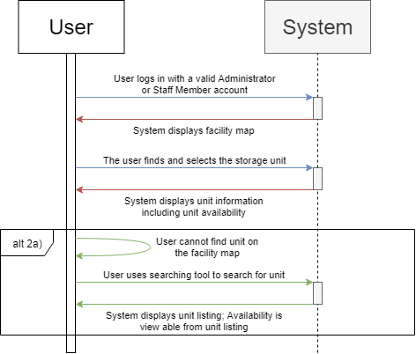

*Figure 9: UCSFI-03 Sequence Diagram*

**Use Case UCSFI-04: Adding a new storage unit in the facility3**

Actors: Administrators

Precondition: The user is logged into the system with an Administrator account.

Steps:

1. The user selects add new storage unit
2. A unit creation view is displayed to the user
3. The user inputs the unit number, dimensions, and cost to rent the new storage unit
4. The user selects a location on the map for the new unit

Success Condition: The new storage unit is created and displayed at the selected location with its unit availability set to ‘available’

Exceptions:

* 3a) The user cancels before submitting unit number, dimensions, and cost. The storage unit is not added to the map. The use case ends.
* 3b) The user submits with a unit number that is already in use. The system displays an error message informing the user and does not proceed to the map.
* 4a) The user cancels before submitting a selected location. The storage unit is not added to the map. The use case ends.

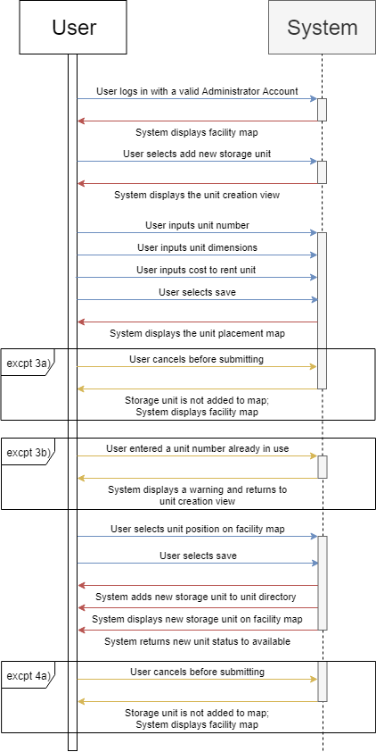

*Figure 10: UCSFI-04 Sequence Diagram*

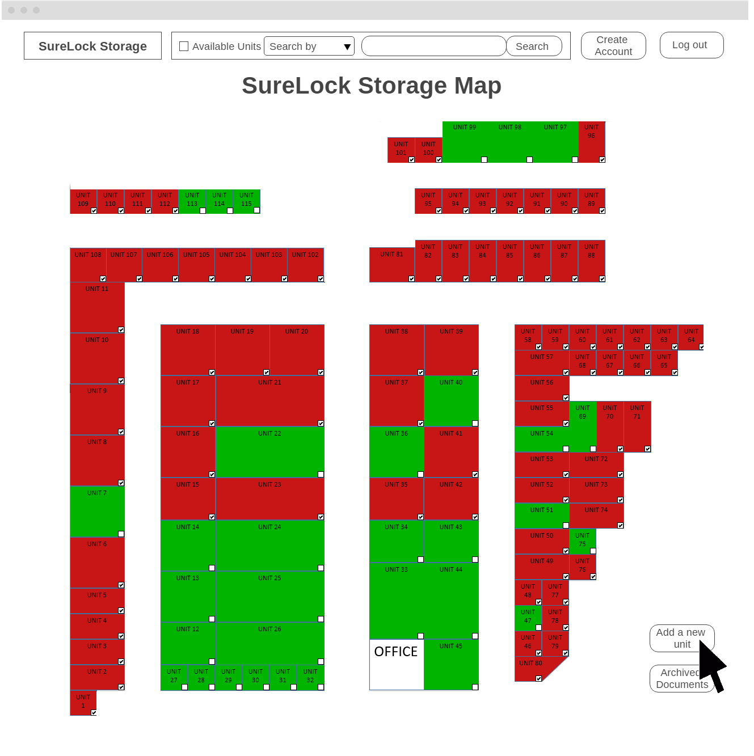

*Figure 10.1: UCSFI-04 UI Screen 1 – Facility Map*

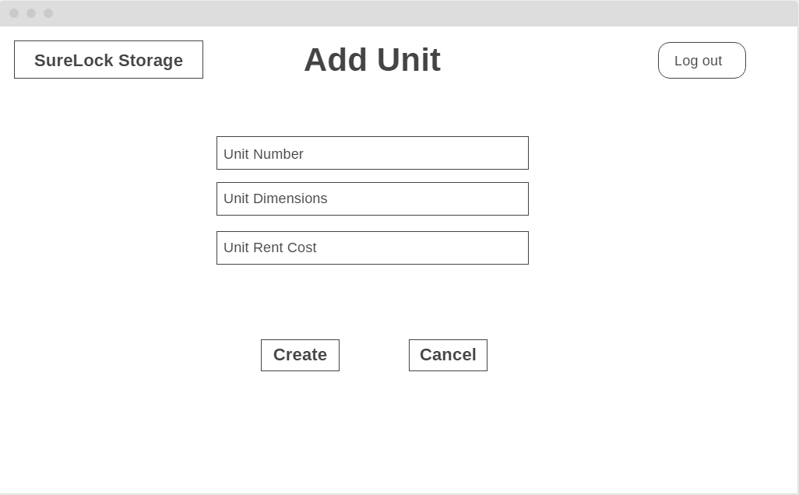

*Figure 10.2: UCSFI-04 UI Screen 2 – Add Unit Screen*

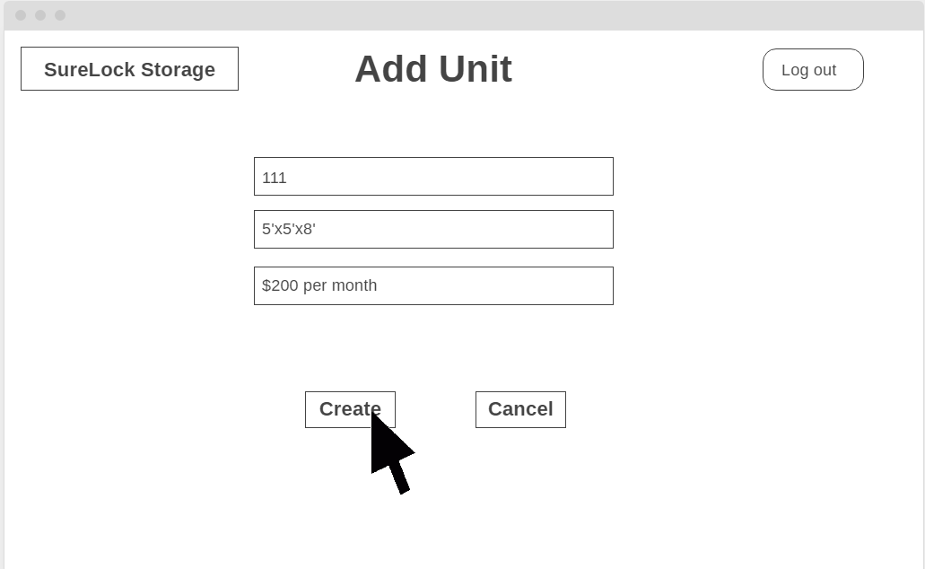

*Figure 10.3: UCSFI-04 Exception 3b: UI Screen 1 – Add Unit Screen Existed Unit Number*

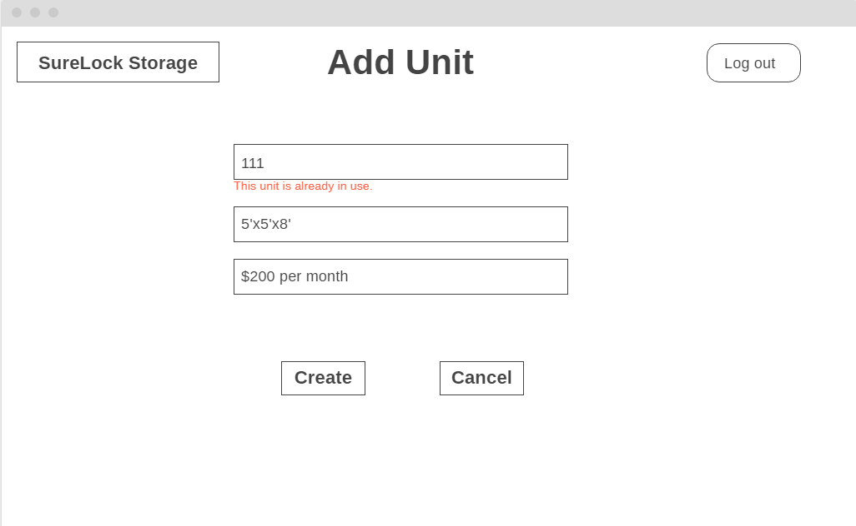

*Figure 10.4: UCSFI-04 Exception 3b: UI Screen 2 – Add Unit Screen Existed Unit Number Message*

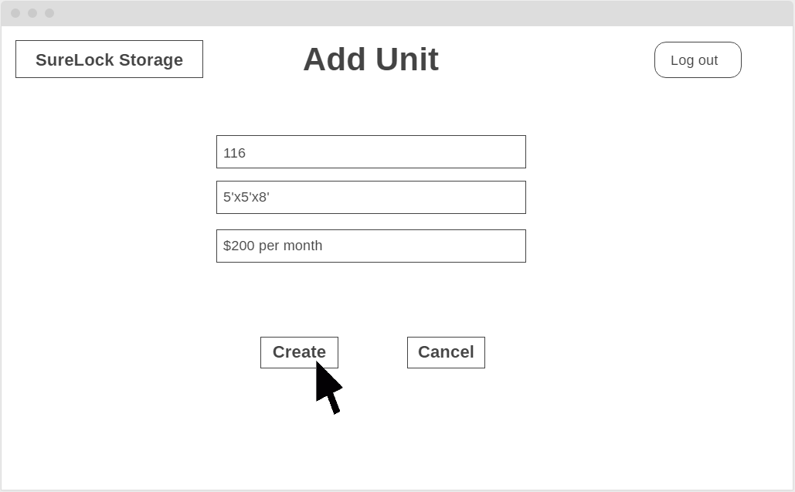

*Figure 10.5: UCSFI-04 UI Screen 3 – Add Unit Screen Filled In*

*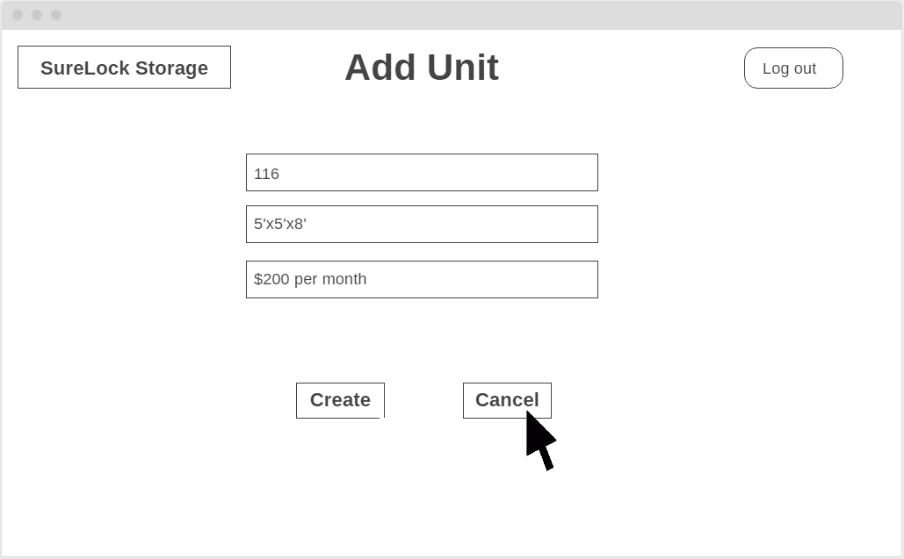 Figure 10.6: UCSFI-04 UI Exception 3a: UI Screen 1 – Cancel Add Unit Screen Filled In*

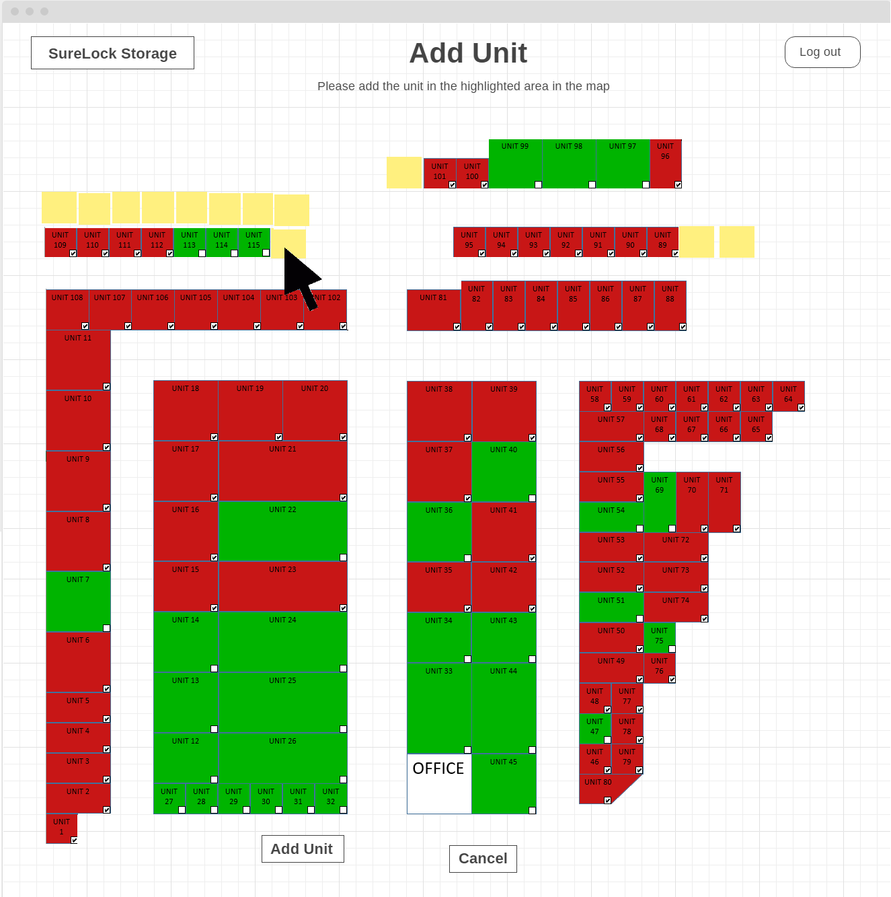

*Figure 10.7: UCSFI-04 UI Screen 4 – Add Unit Screen*

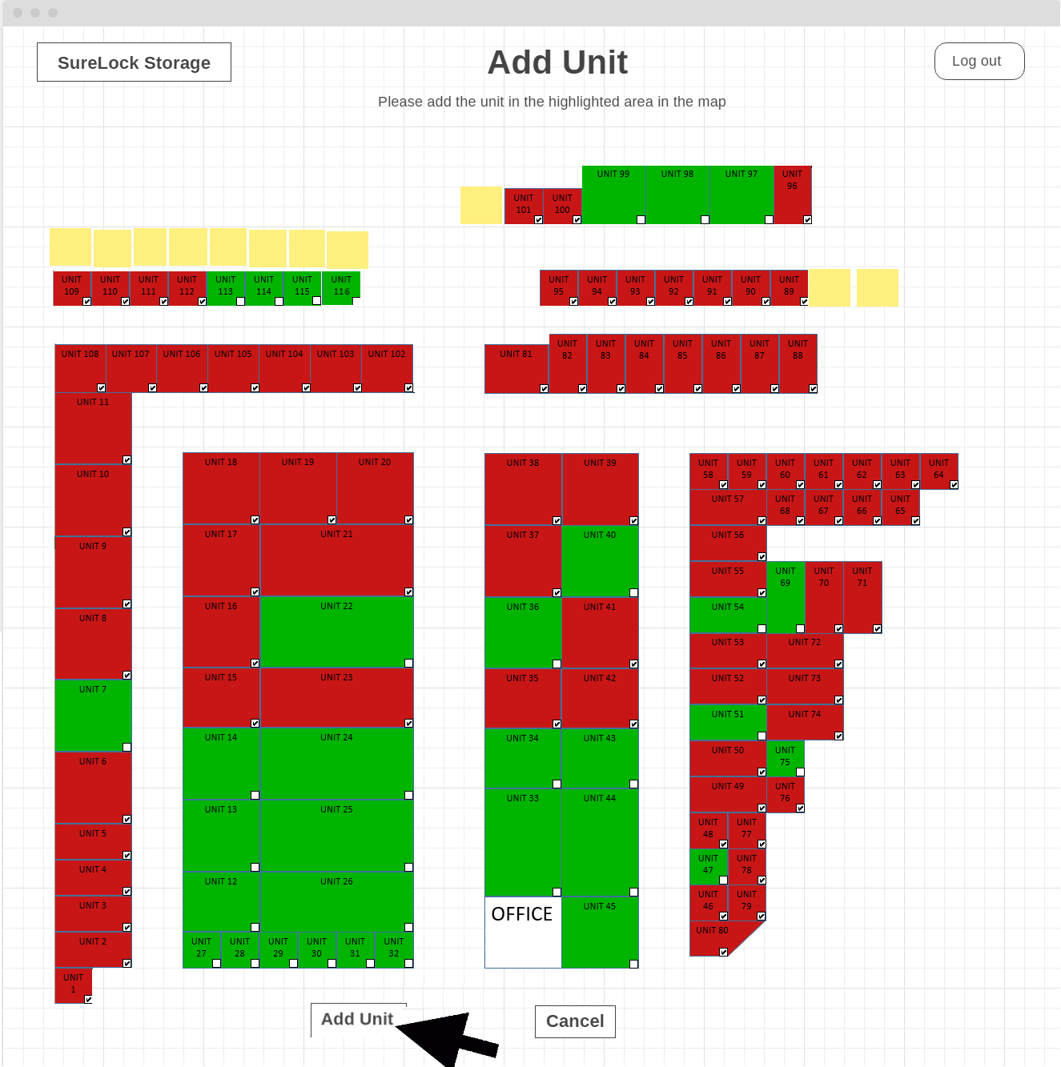

*Figure 10.8: UCSFI-04 UI Screen 5 – Add Unit Screen with Unit 116*

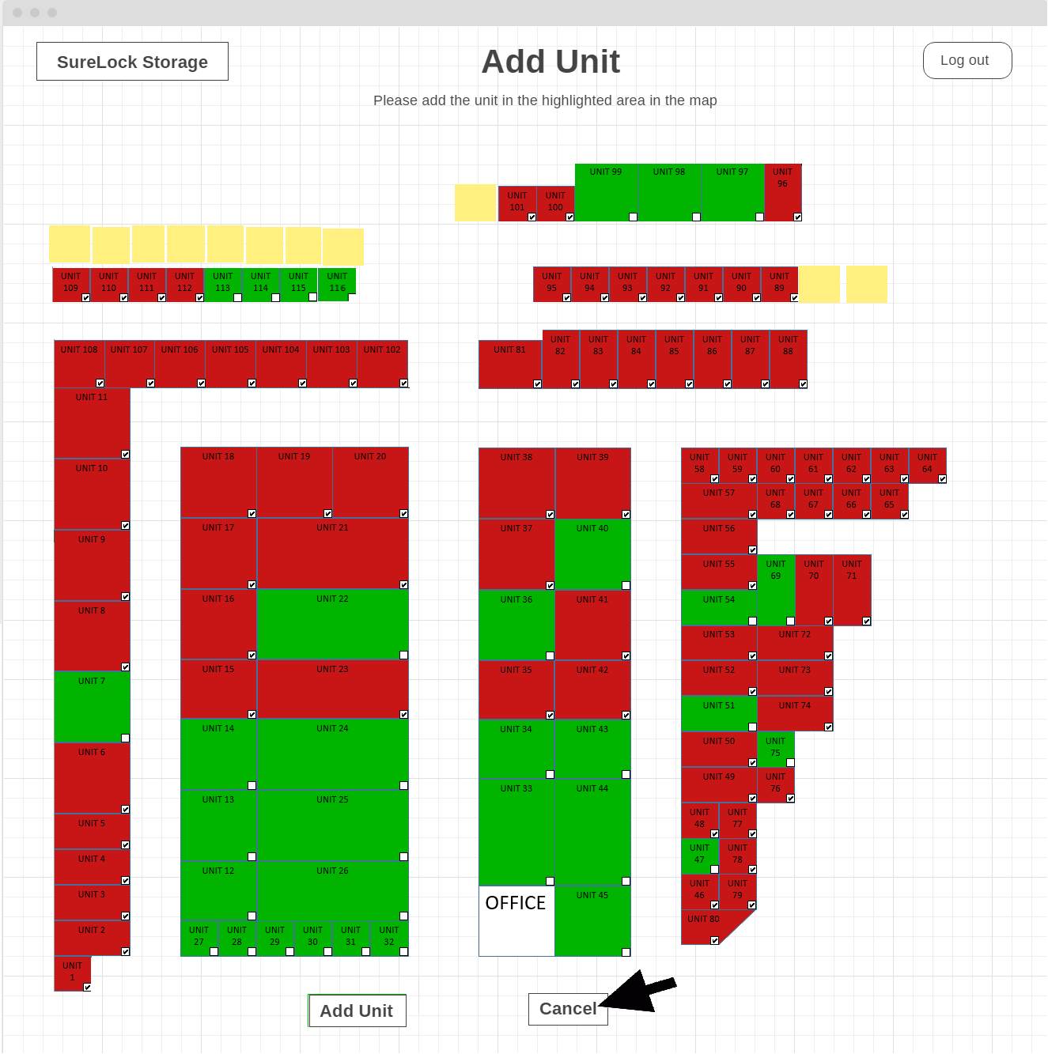

*Figure 10.9: UCSFI-04 Exception 4a: UI Screen 1 – Cancel Add Unit Screen with Unit 116*

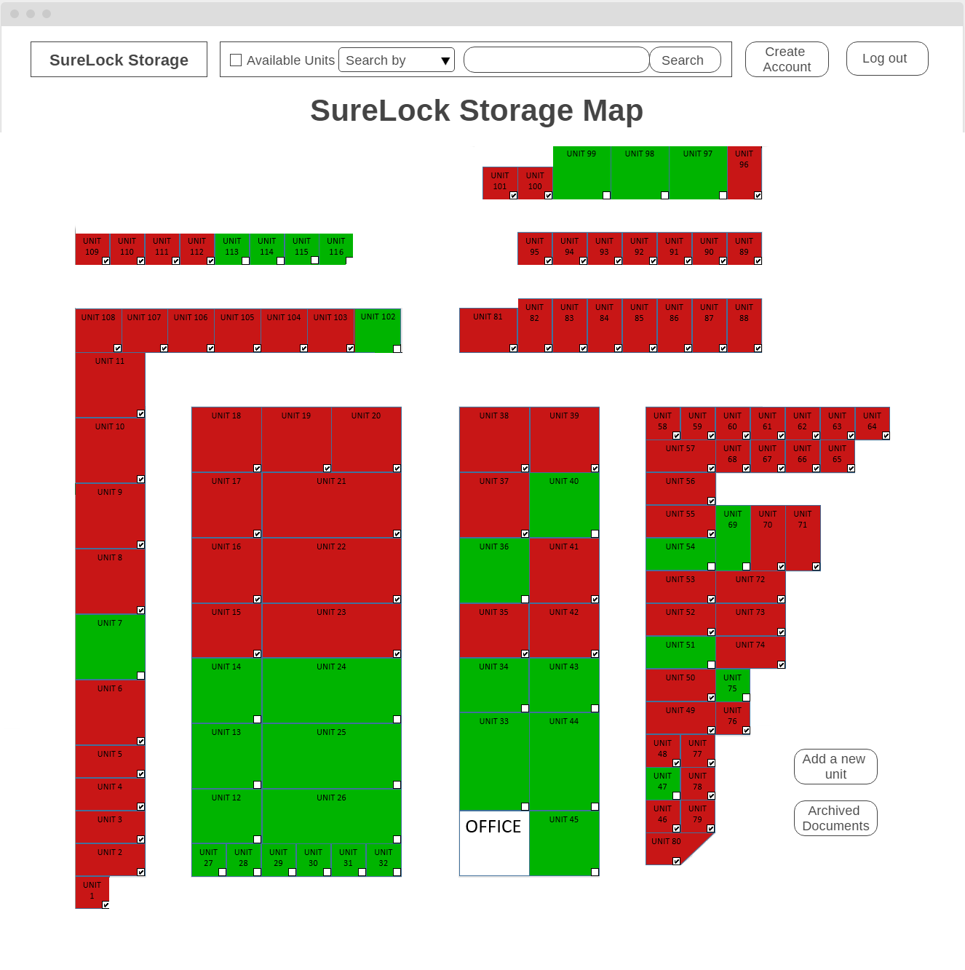

*Figure 10.10: UCSFI-04 UI Screen 5 – Map Screen with Unit 116*

The Administrator clicks “Add a new unit”. After entering a unit number, dimension, and cost, click “Create” to confirm the information the Administrator typed. After that, the Administrator would be directed to the map, where the Administrator is able to choose where they want to add a new unit. After clicking the position on the map, the Administrator clicks “Add Unit” to confirm the position. Then, the system displays the map with the new unit added.

**Use Case UCSFI-05: Removing client from unit**

Actors: Administrators

Preconditions:

* The user is logged into the system with an Administrator account
* There exists a unit with an associated client

Steps:

1. The user selects a unit which is ‘not available’
2. The unit information is displayed
3. The user selects edit
4. The user selects to remove client from unit
5. The system asks for confirmation
6. The user confirms intent to remove client from unit

Success Condition: The system removes all client information from the unit and sets the unit to ‘available’. Removed transaction documents will be archived.

Exception: 6a) The user cancels before submitting. The client is not removed. The use case ends.

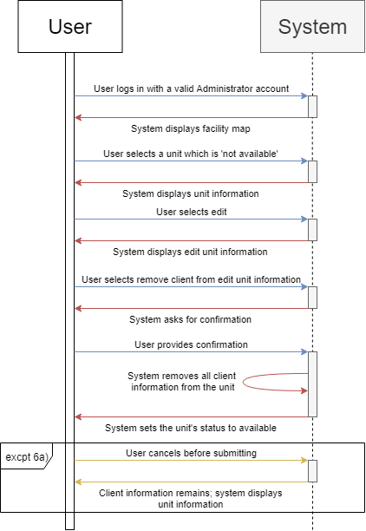

*Figure 11: UCSFI-05 Sequence Diagram*

### 7.3.3 Storage Unit Information Use Cases

**Use Case UCSUI-01: Viewing Unit Information (Unrestricted for Administrators)**

Actors: Administrators

Precondition: The user has logged in to the system under an Administrator account

Steps:

1. The user selects a specific unit from the map
2. The system displays the following information that corresponds to the selected unit:
   * Unit Number
   * Unit Dimensions
   * Unit Availability
   * Unit Rent Cost
   * Unit Current Balance
   * Client’s Full Name
   * Client’s Email
   * Client’s Phone Number
   * Client’s Payment Methods
   * Transaction Documents
   * Last Payment Date
   * Annotations

Success Condition: The user is now viewing unit information for the selected unit

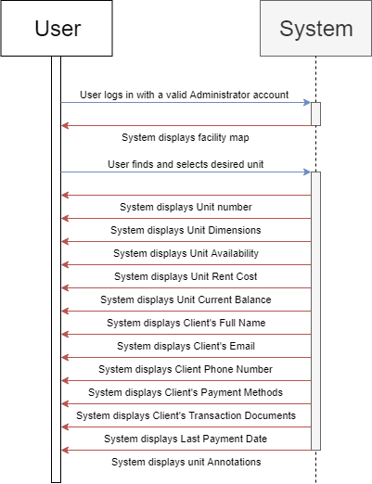

*Figure 12: UCSUI-01 Sequence Diagram*

**Use Case UCSUI-02: Viewing Restricted Unit Information**

Actors: Staff Members

Precondition: The user has logged in to the system under a Staff Member account

Steps:

1. The user selects a specific unit from the map
2. The system displays the following information that corresponds to the selected unit:
   * Unit Number
   * Unit Dimensions
   * Unit Availability
   * Unit Rent Cost
   * Client’s Full Name
   * Client’s Email
   * Client’s Phone Number
   * Annotations

Success Condition: The user is now viewing unit information for the selected unit

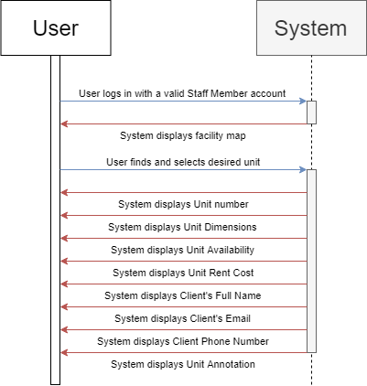

*Figure 13: UCSUI-02 Sequence Diagram*

**Use Case UCSUI-03: Annotating Units**

Actors: Administrators and Staff Members

Precondition: The user has logged in under a valid account

Steps:

1. The user selects a specific unit
2. The information regarding that unit will be displayed
3. The user selects edit
4. The user navigates to the annotation field
5. The user adds their comments to the unit
6. The user selects to save the annotation

Success Condition: The annotations for the selected unit are saved and will be viewable by any user of the system

Exception: 6a) The user cancels their unit annotation before submitting. The annotation is not saved to the unit information. The use case ends

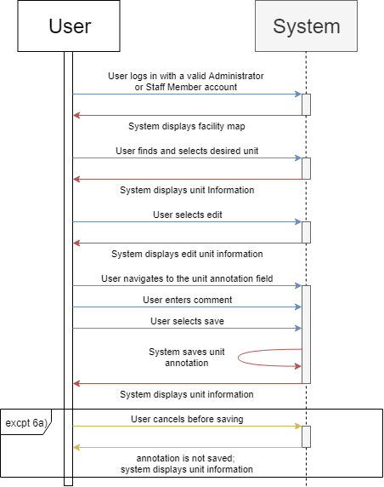

*Figure 14: UCSUI-03 Sequence Diagram*

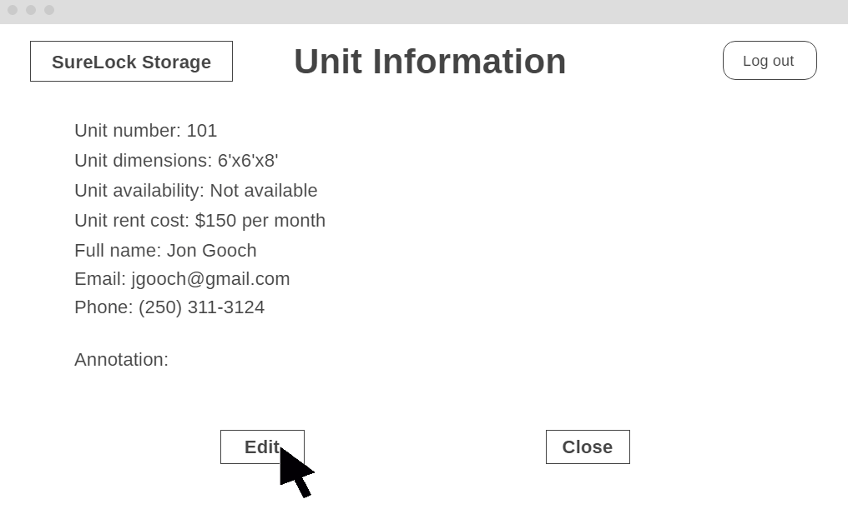

*Figure 14.1: UCSUI-04 UI Screen 1 – Unit Information Screen*

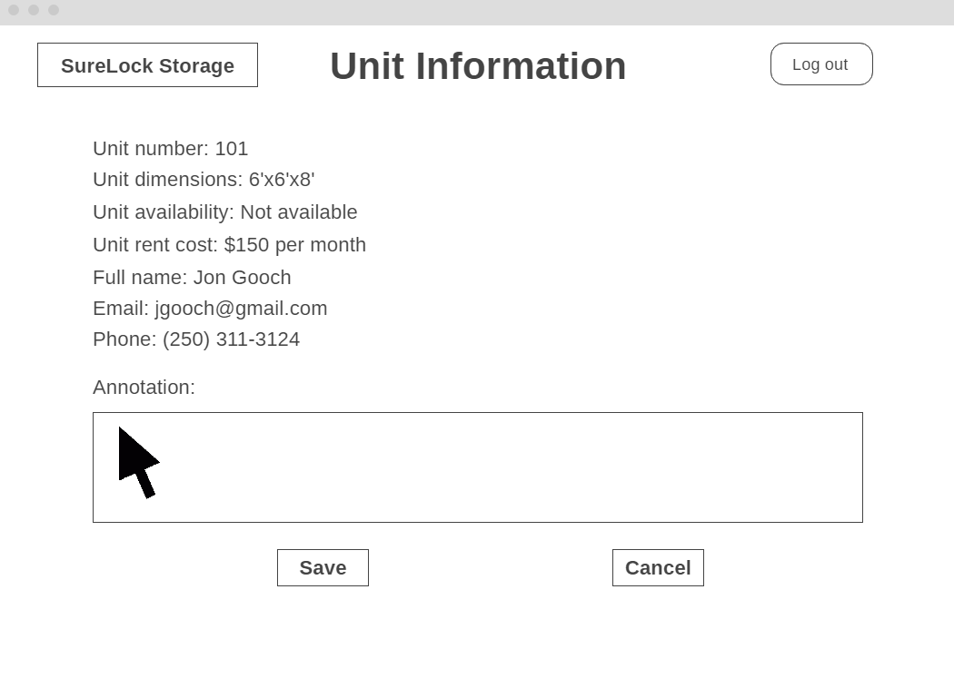

*Figure 14.2: UCSUI-04 UI Screen 2 – Unit Information Editing Screen*

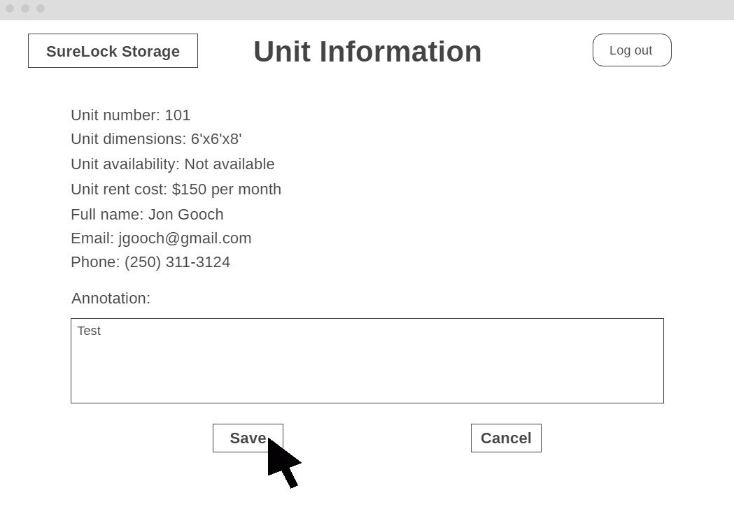

*Figure 14.3: UCSUI-04 UI Screen 3 – Unit Information Editing Screen with Annotation*

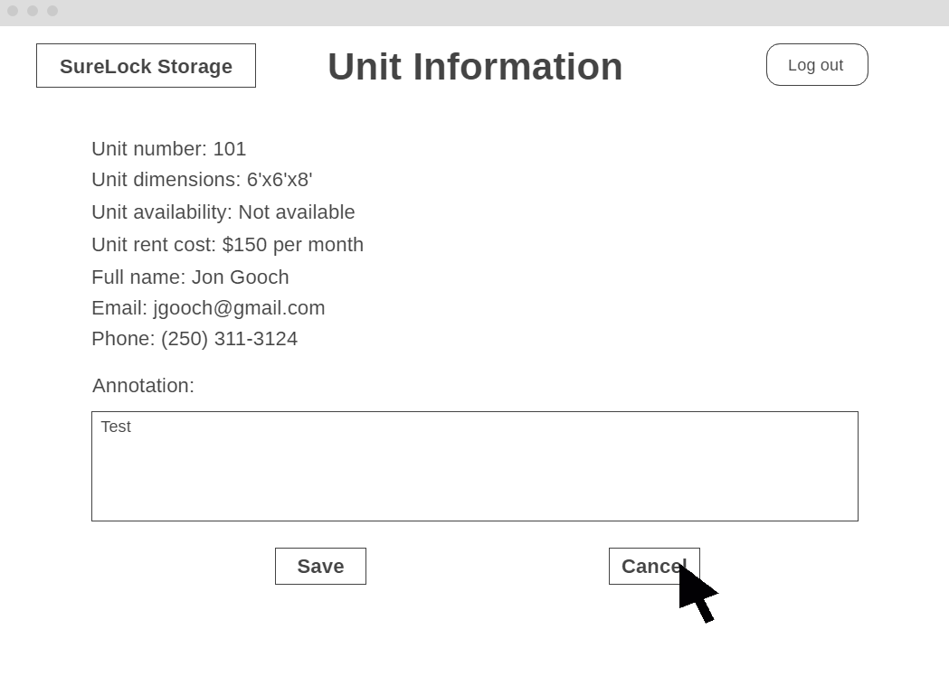

*Figure 14.4: UCSUI-04 Exception 6a: UI Screen 1 – Unit Information Editing Screen with Annotation*

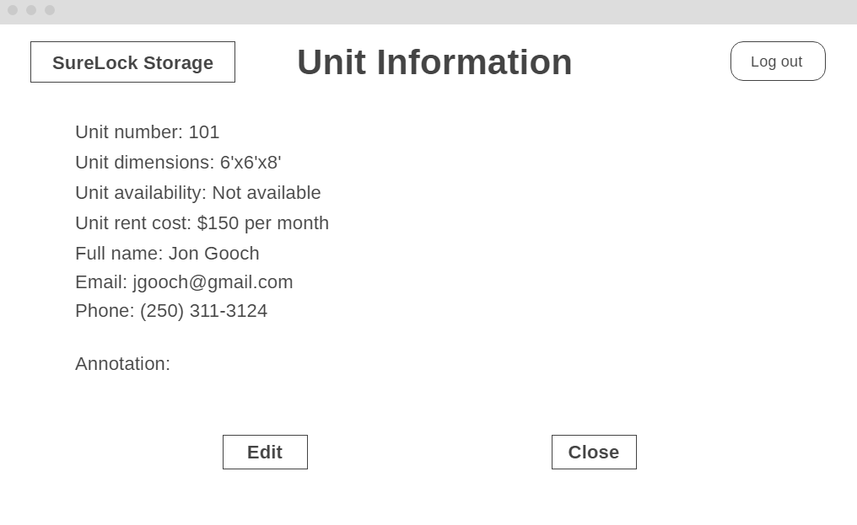

*Figure 14.5: UCSUI-04 Exception 6a: UI Screen 2 – Canceled Unit Information Screen*

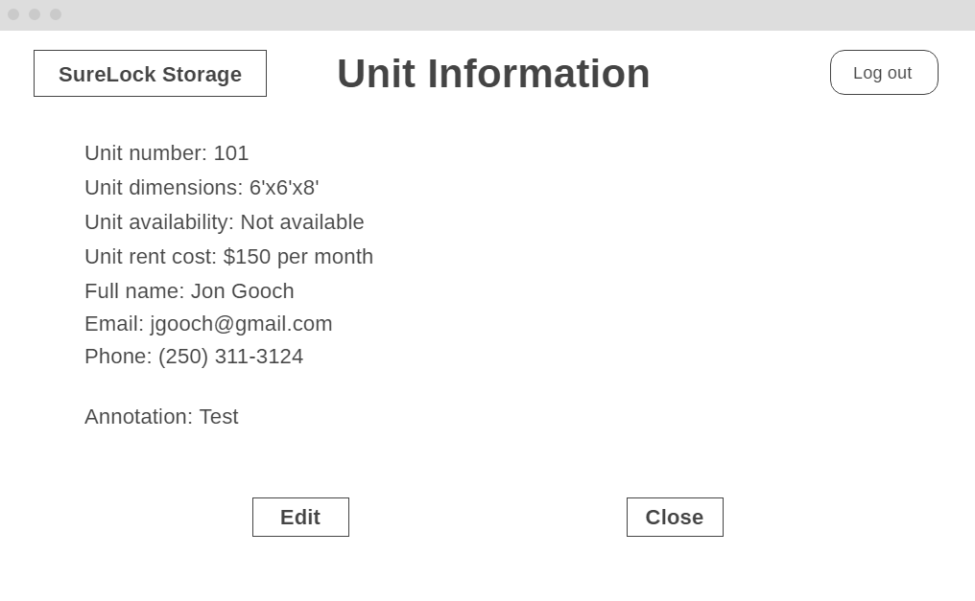

*Figure 14.6: UCSUI-04 UI Screen 4 – Unit Information Screen with Annotation*

The user clicks a specific unit on the map, which directs the user to the Unit Information page. By clicking “Edit”, the user can add an annotation. To save the annotation as Unit Information, the user clicks “Save”.

**Use Case UCSUI-04: Removing an Annotation**

Actors: Administrators and Staff Members

Preconditions:

* The user has logged in under a valid account
* There exists a unit with an annotation on its information page

Steps:

1. The user selects the desired unit from the facility map
2. The unit information for the selected unit is displayed
3. The user selects edit
4. The user navigates to the annotation field
5. The user removes the comment
6. The user selects save

Success Condition: The annotation is removed from the Unit Information

Exception: 6a) The user cancels their unit annotation before submitting. The original annotation remains. The use case ends.

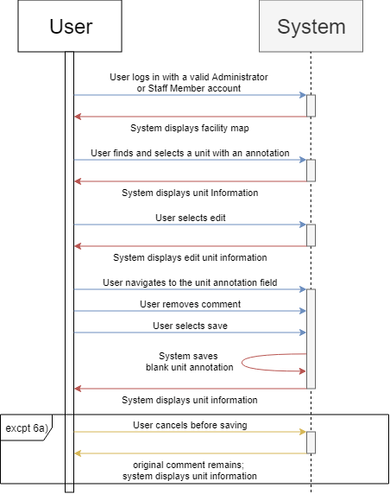

*Figure 15: UCSUI-04 Sequence Diagram*

**Use Case UCSUI-05: Balance Update**

Actors: Administrators

Precondition:

* The user has logged in under an Administrator account
* There exists a unit with an associated client

Steps:

1. The user selects a unit from the facility map
2. The unit information for the selected unit is displayed
3. The user selects to edit the Unit Information.
4. The user selects the payment method
5. The user enters a payment amount
6. The user selects to save the Unit Information

Success Condition: The system updates and decreases the current balance correspondingly

Alternate Path: 3a) The user also adds a transaction document to the unit information. The system displays a confirmation message of success.

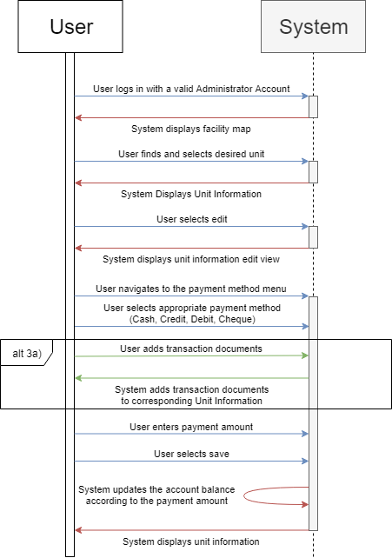

*Figure 16: UCSUI-05 Sequence Diagram*

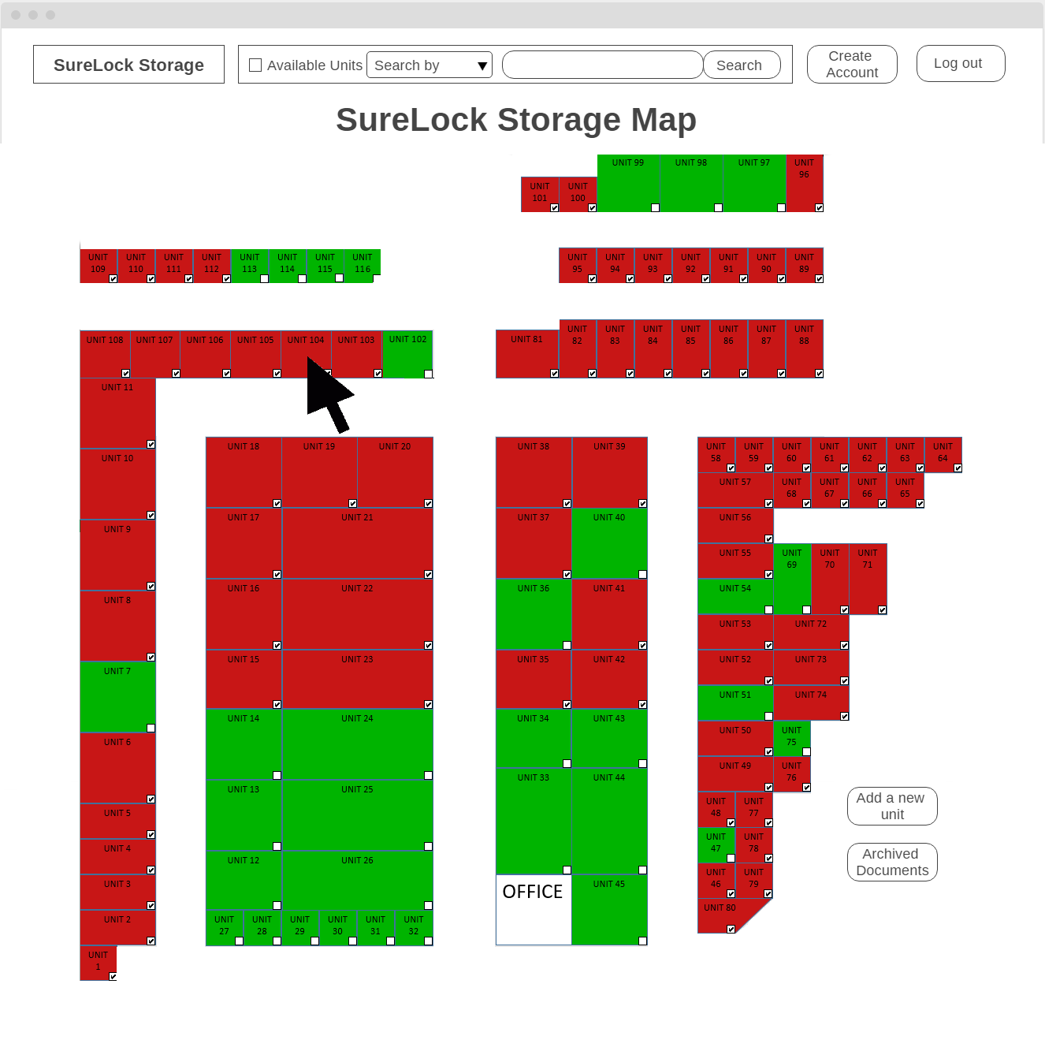

*Figure 16.1: UCSUI-05 UI Screen 1 – Map Screen*

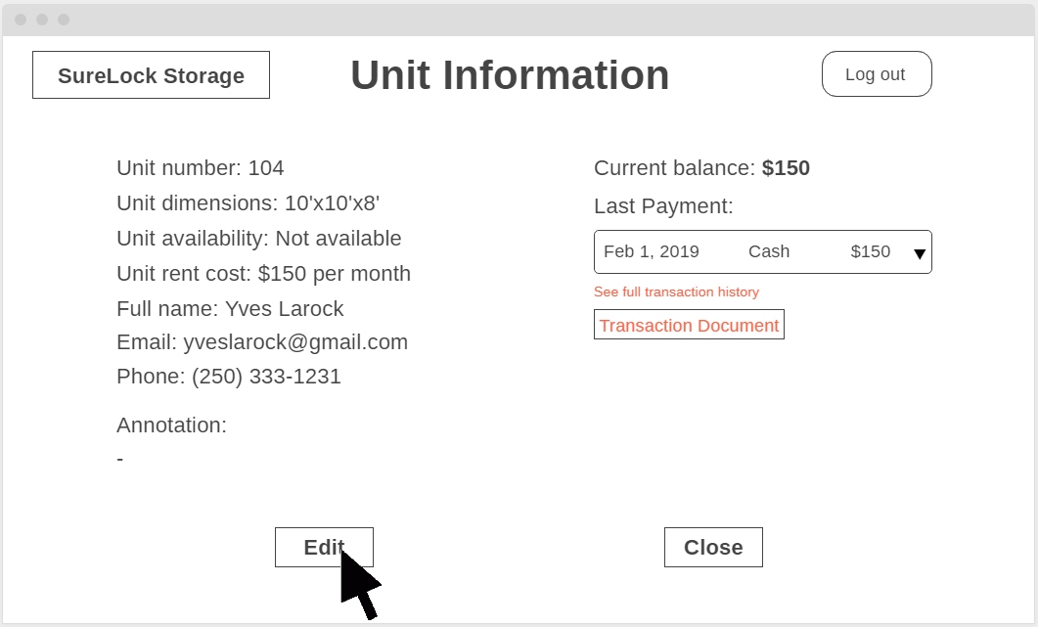

*Figure 16.2: UCSUI-05 UI Screen 2 – Unit Information Screen*

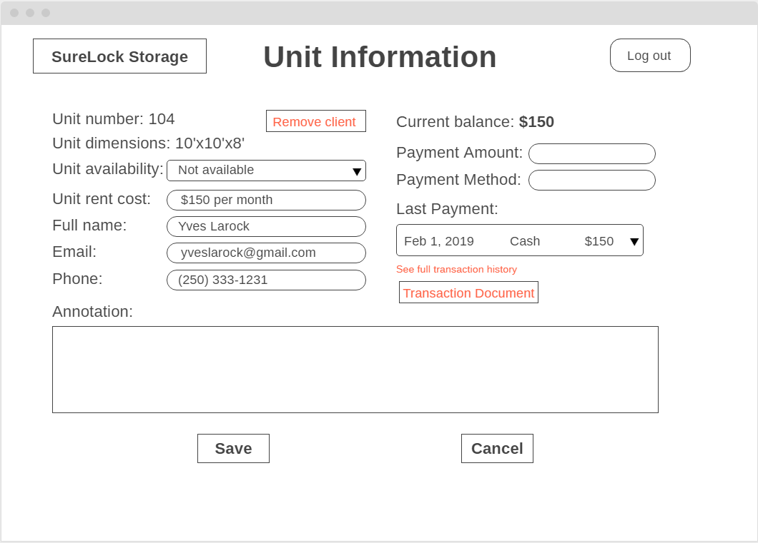

*Figure 16.3: UCSUI-05 UI Screen 3 – Unit Information Editing Screen*

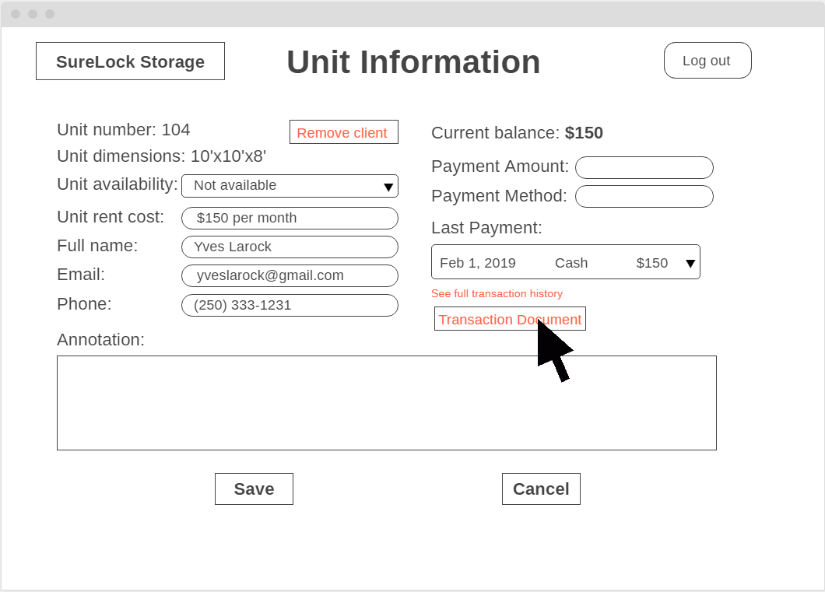

*Figure 16.4: UCSUI-05 Alternate 3a: UI Screen 1 – Unit Information Editing Screen Selecting Transaction Document*

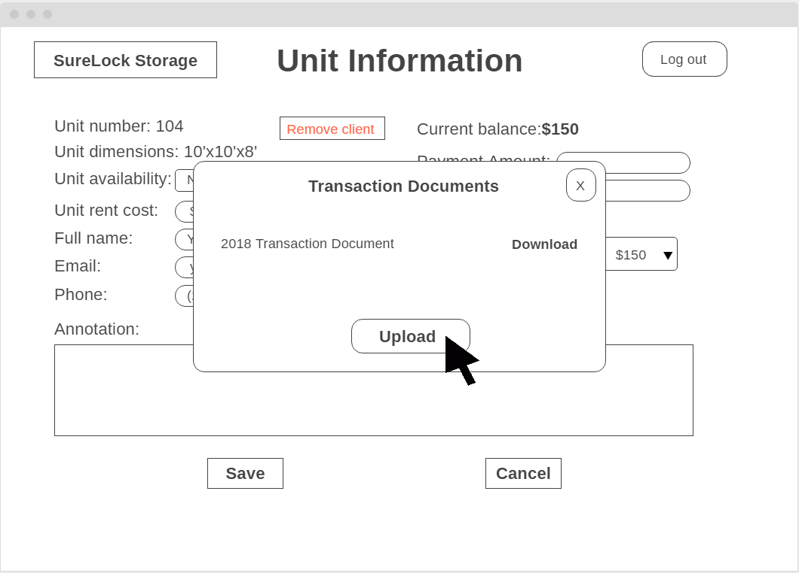

*Figure 16.5: UCSUI-05 UI Alternate 3a: UI Screen 2 – Uploading Transaction Document Screen*

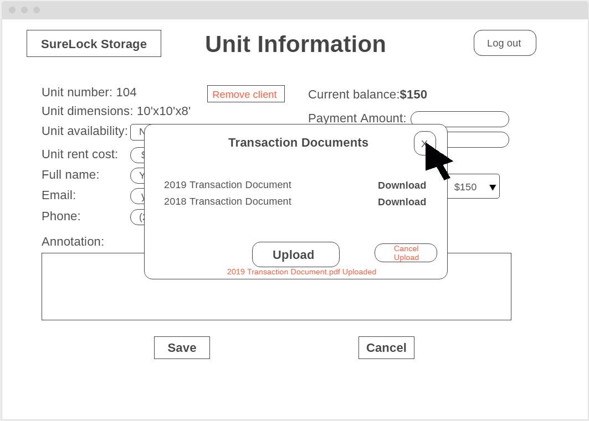

*Figure 16.6: UCSUI-05 UI Alternate 3a: UI Screen 3 – Uploaded Transaction Document Screen*

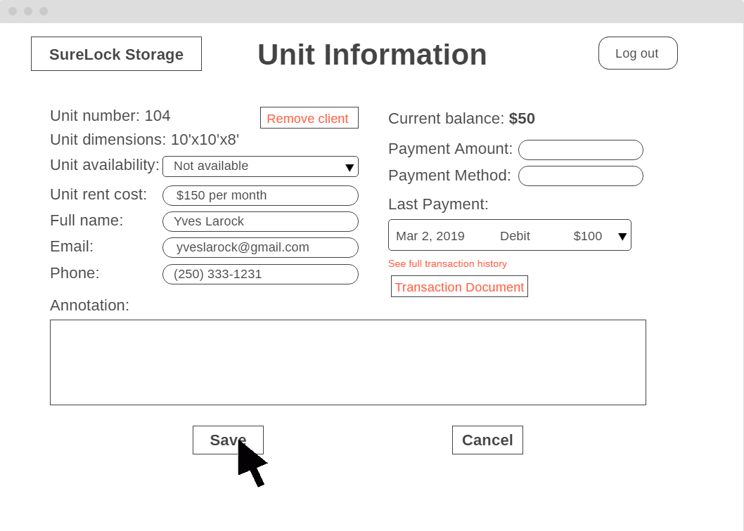

*Figure 16.7: UCSUI-05 Alternate 3a: UI Screen 4 – Save Unit Information Screen*

*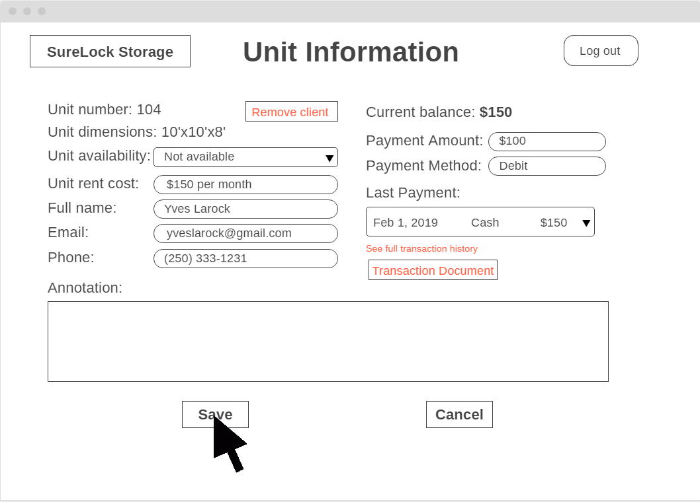Figure 16.8: UCSUI-05 UI Screen 4 – Save Unit Information Screen*

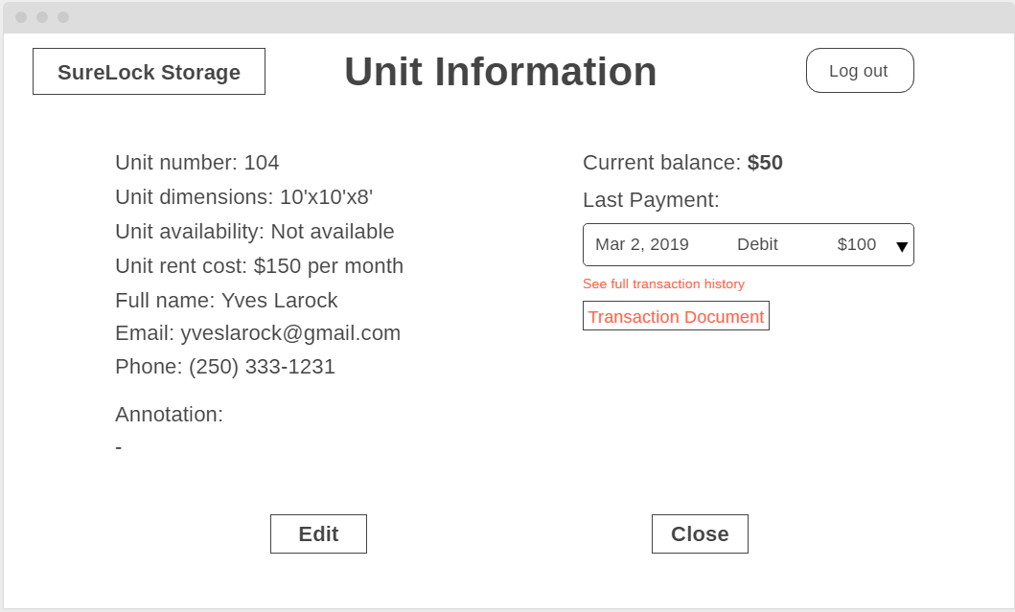

*Figure 16.9: UCSUI-05 UI Screen 4 – Updated Unit Information Screen*

The Administrator clicks on a unit in the facility map. The Administrator is directed to the unit information page of the selected unit. The Administrator selects the payment method and enters a payment amount. This updates the current balance corresponding to the amount paid. The Administrator will also be able to upload a transaction document by clicking on the “Upload” button; a success message will be displayed after the file has been uploaded.

**Use Case UCSUI-06: Edit Unit Information**

Actors: Administrators

Precondition: The user has logged in under an Administrator account

Steps:

1. The user selects a unit from the map
2. The user views the information specified in UCSUI-01
3. The user selects to edit the Unit Information
4. The user edits the following fields:

* Unit Rent Cost
* Client’s Full Name
* Client’s Email
* Client’s Phone Number
* Client’s Payment Amount
* Client’s Payment Methods

1. The user selects to save the Unit Information.

Success Condition: The user views the updated Unit Information

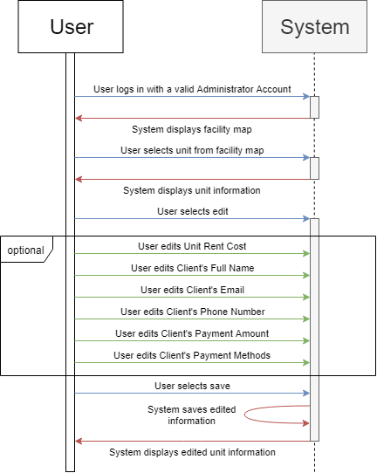

*Figure 17: UCSUI-06 Sequence Diagram*

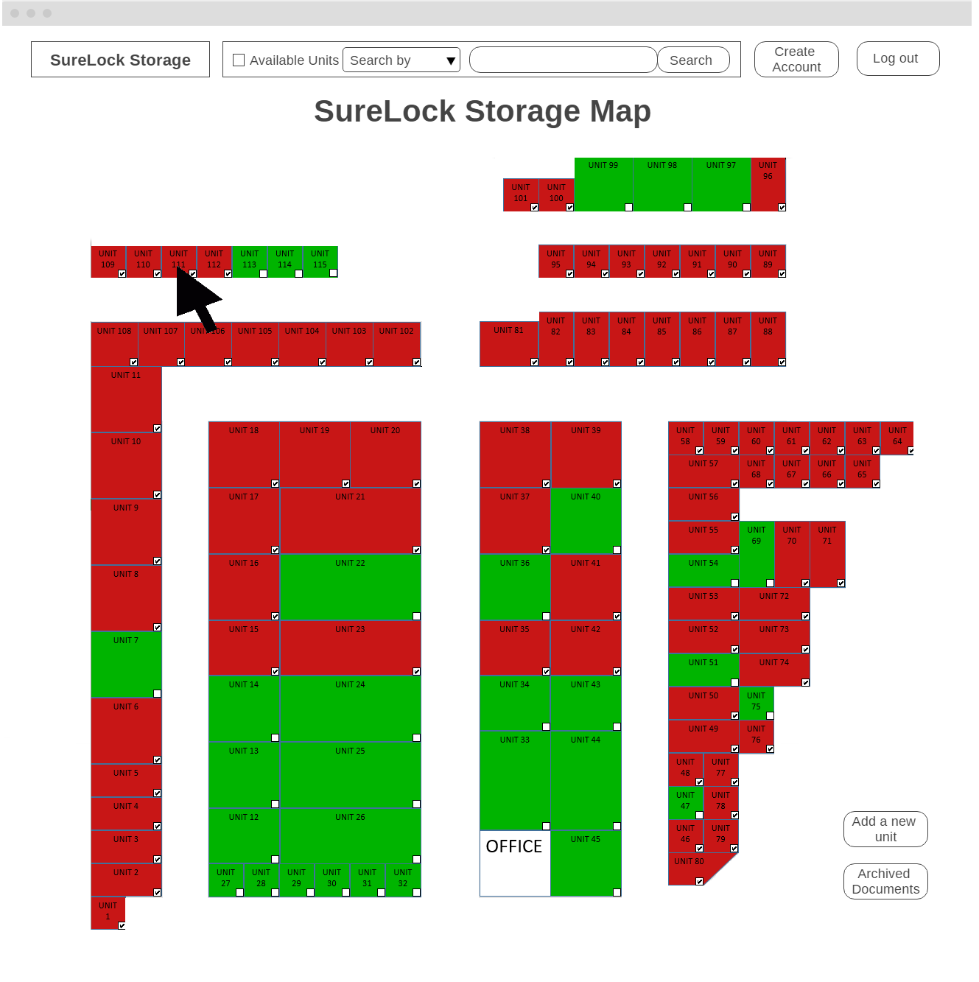

*Figure 17.1: UCSUI-06 UI Screen 1 – Map Screen*

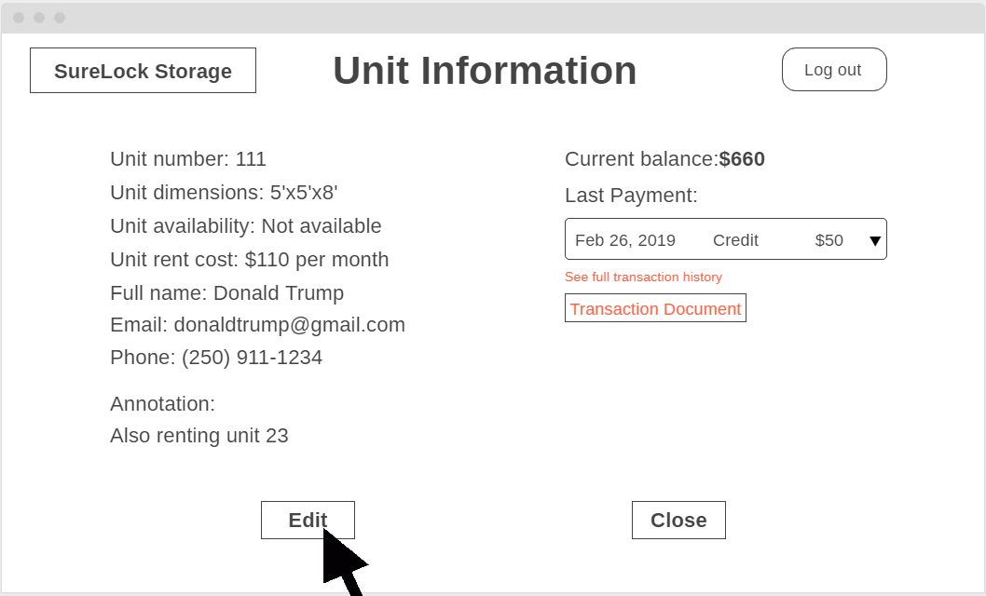

*Figure 17.2: UCSUI-06 UI Screen 2 – Unit Information Screen*

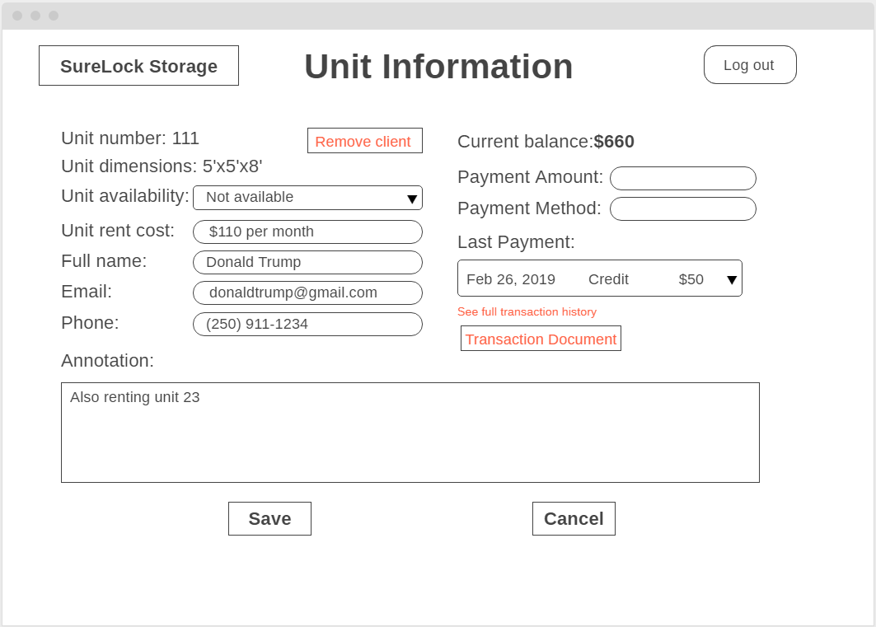

*Figure 17.3: UCSUI-06 UI Screen 3 – Unit Information Editing Screen*

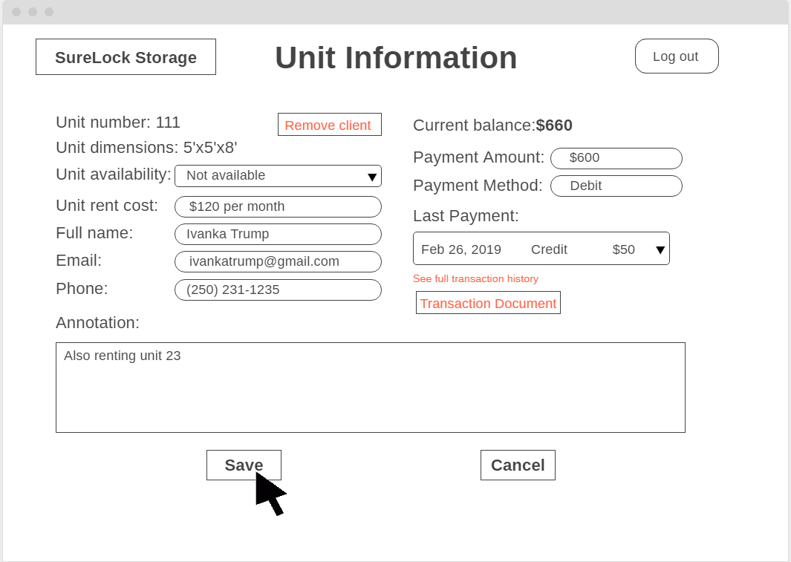

*Figure 17.4: UCSUI-06 UI Screen 4 – Unit Information Editing Screen Edited*

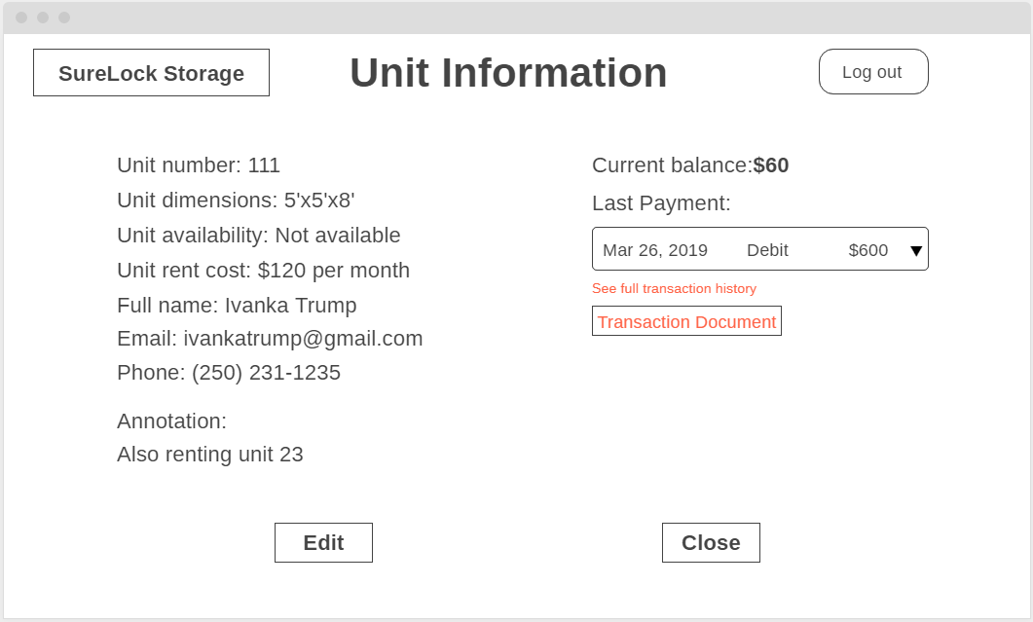

*Figure 17.5: UCSUI-06 UI Screen 5 – Unit Information Screen Edited*

The Administrator selects the unit in the facility map. The Administrator views the Unit Information. The Administrator selects the “Edit” button to enter the edit mode of the Unit Information. The Administrator edits the unit availability, unit rent cost, unit current balance, client’s full name, client’s email, client’s phone number, client’s payment methods, transaction documents, and last payment date. The Administrator selects the “Save” button to save the changes. The Administrator sees the new changes in Unit Information.

### 7.3.4 System Searching Feature Use Cases

**Use Case UCSSF-01: Search by Client Information**

Actors: Administrators and staff members

Precondition: The user has logged in under a valid account

Steps:

1. The user selects the searching feature
2. The user selects to search by full name and enters a client’s full name
3. The system displays one or more units with the full name of the specified client assigned
4. The user selects the desired unit and views the unit information

Success Condition: The desired unit information is displayed to the user

Alternate Paths:

* 2a) The user selects to search by phone number and enters a client’s phone number
* 2b) The user selects to search by email and a client’s email

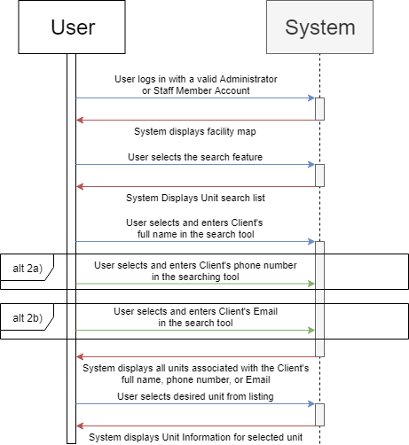

*Figure 18: UCSSF-01 Sequence Diagram*

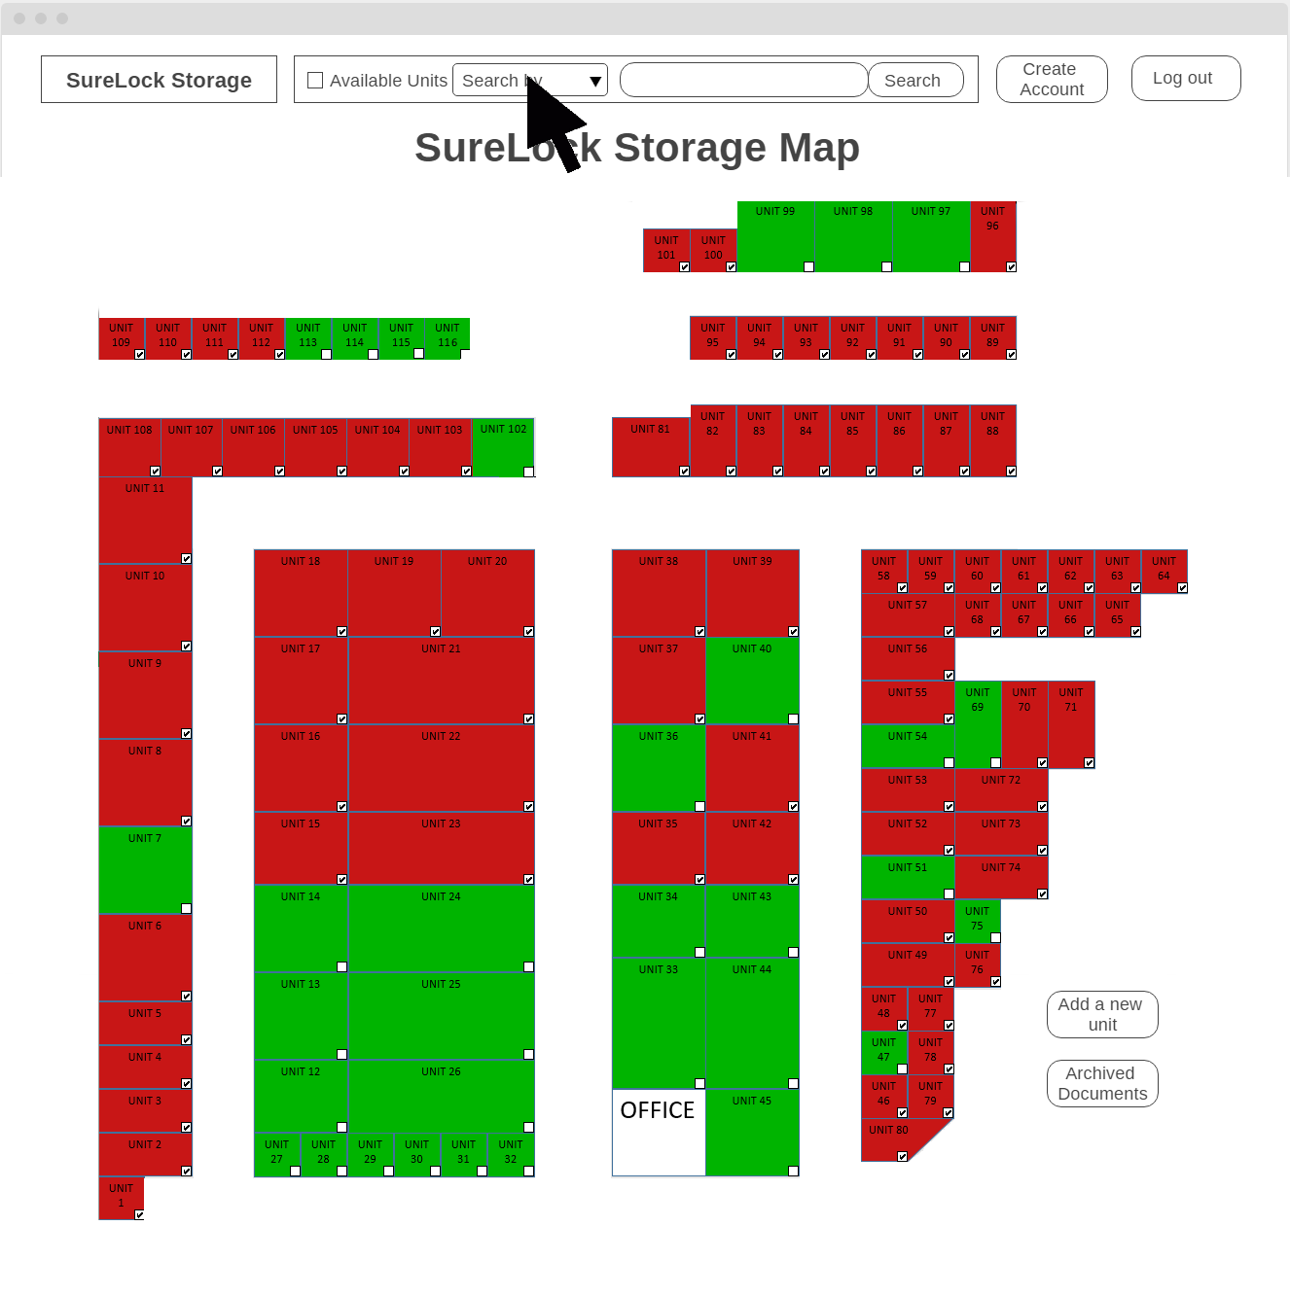

*Figure 18.1: UCSSF-01 UI Screen 1 – Map Screen*

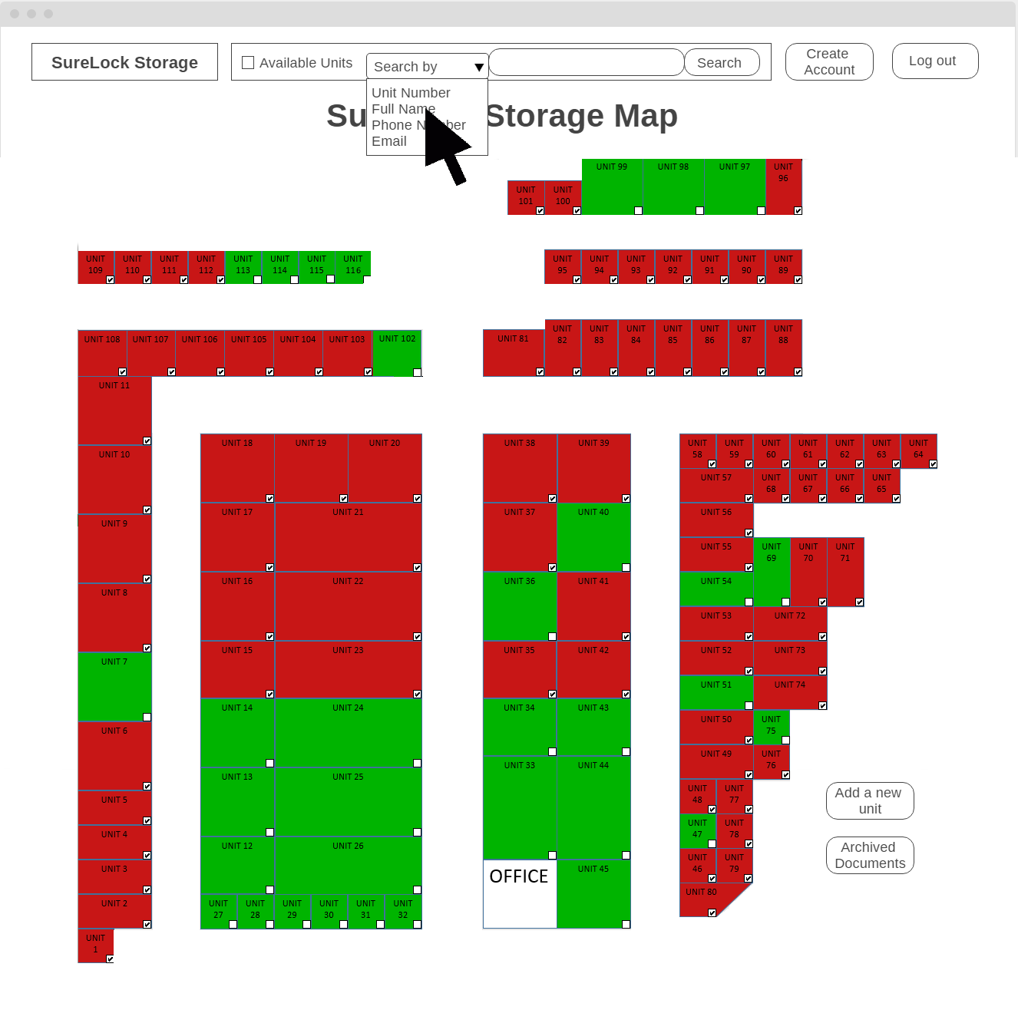

*Figure 18.2: UCSSF-01 UI Screen 2 – Search by Full Name Screen*

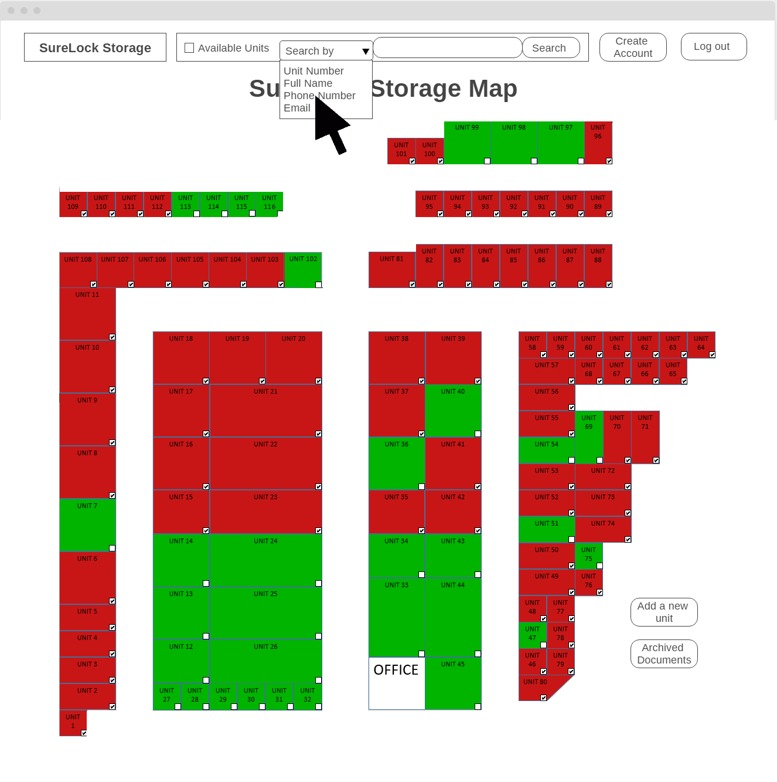

*Figure 18.3: UCSSF-01 Alternate 2a: UI Screen 1 – Search by Phone Number Screen*

*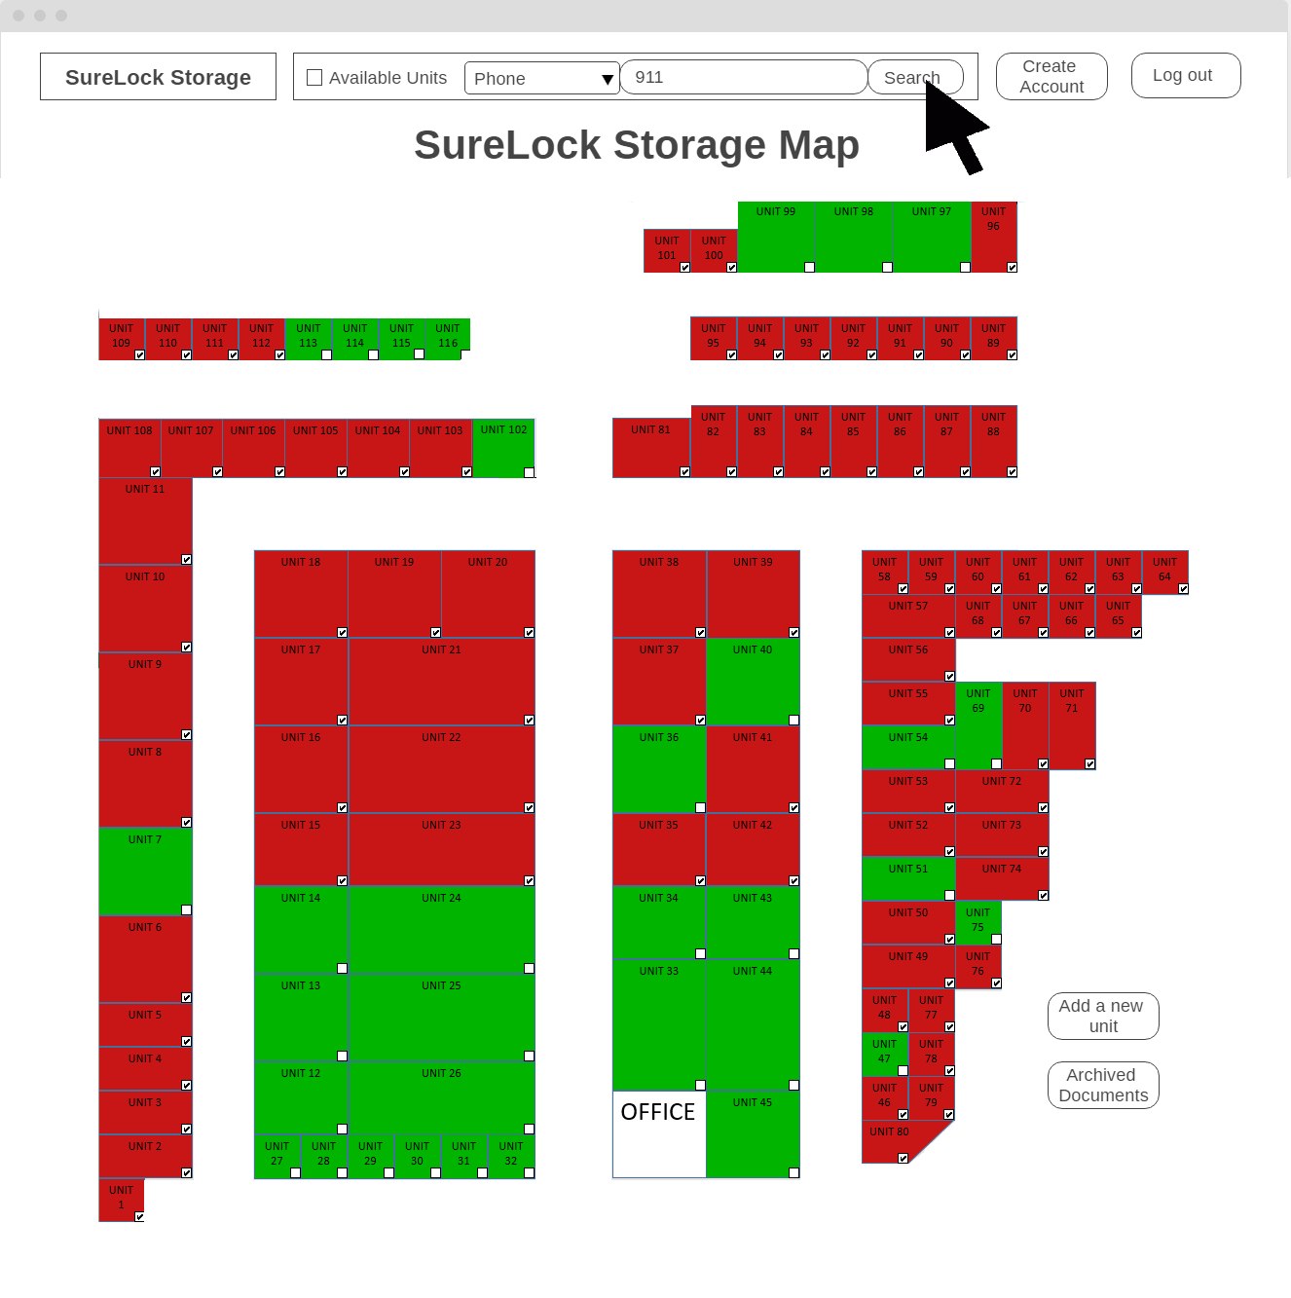Figure 18.4: UCSSF-01 Alternate 2a: UI Screen 2 – Search Phone Number Screen*

*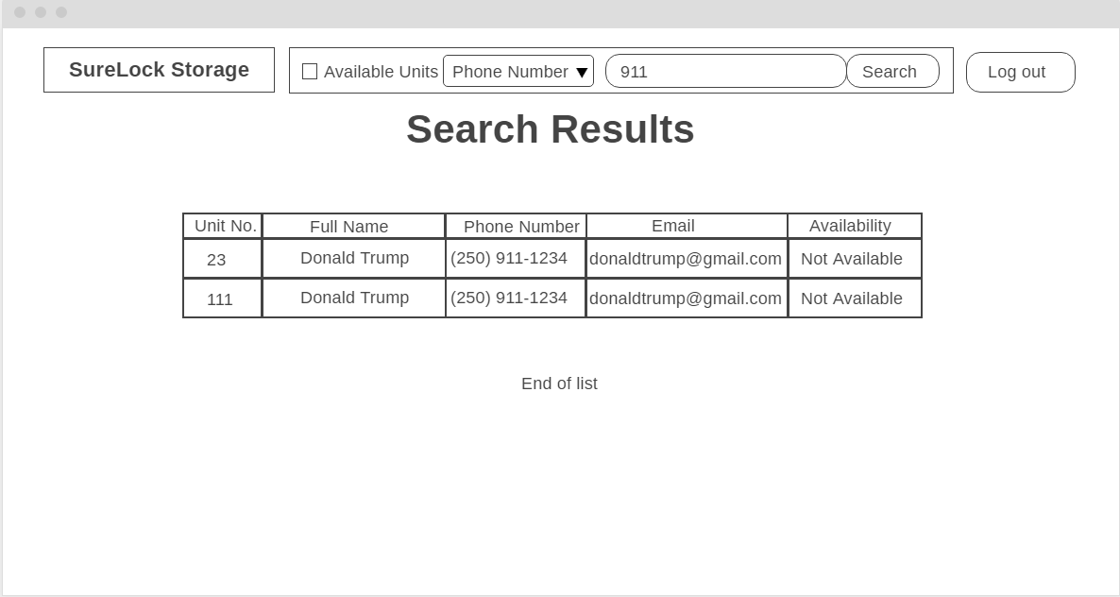Figure 18.5: UCSSF-01 Alternate 2a: UI Screen 3 – Search Phone Number Results Screen*

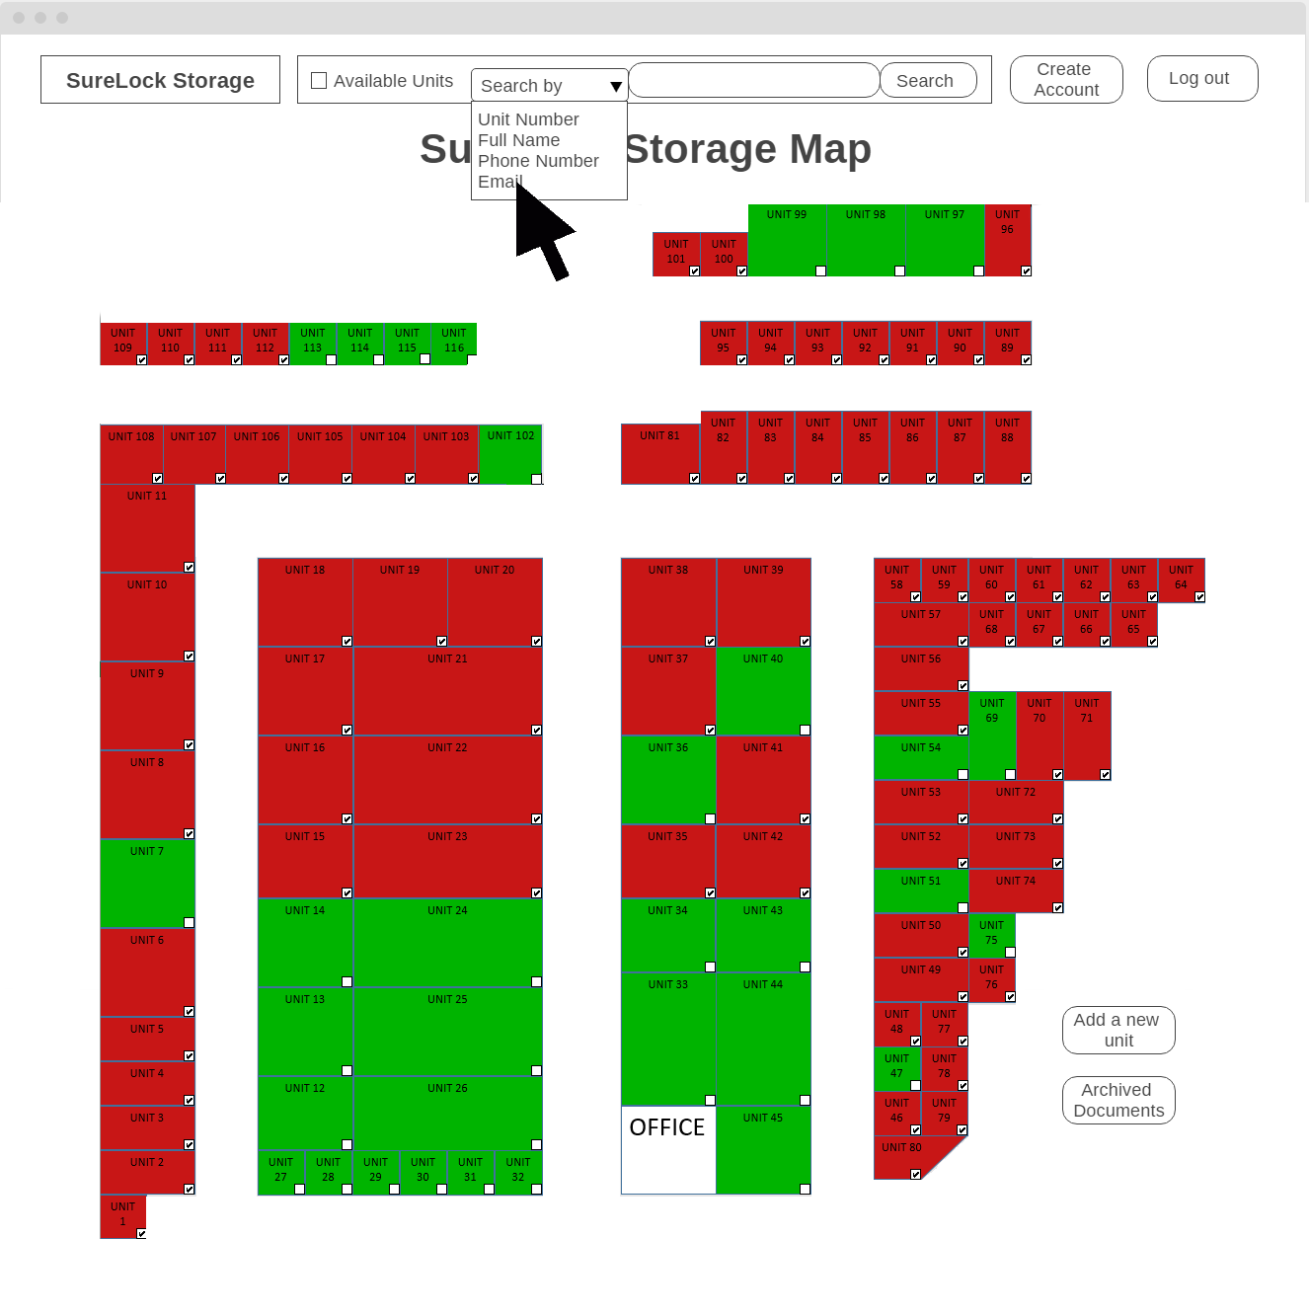

*Figure 18.6: UCSSF-01 Alternate 2b: UI Screen 1 – Search by Email Screen*

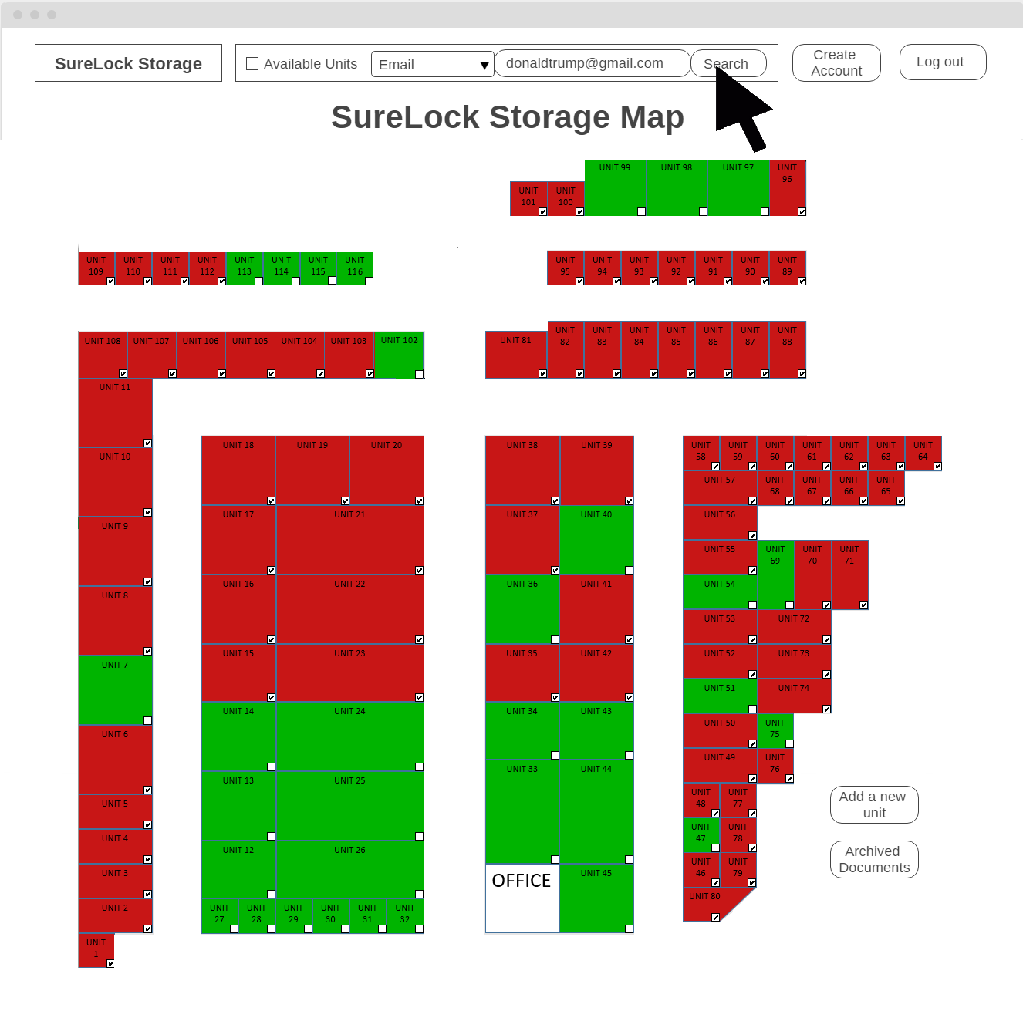

*Figure 18.7: UCSSF-01 Alternate 2b: UI Screen 2 – Search by Email Screen*

*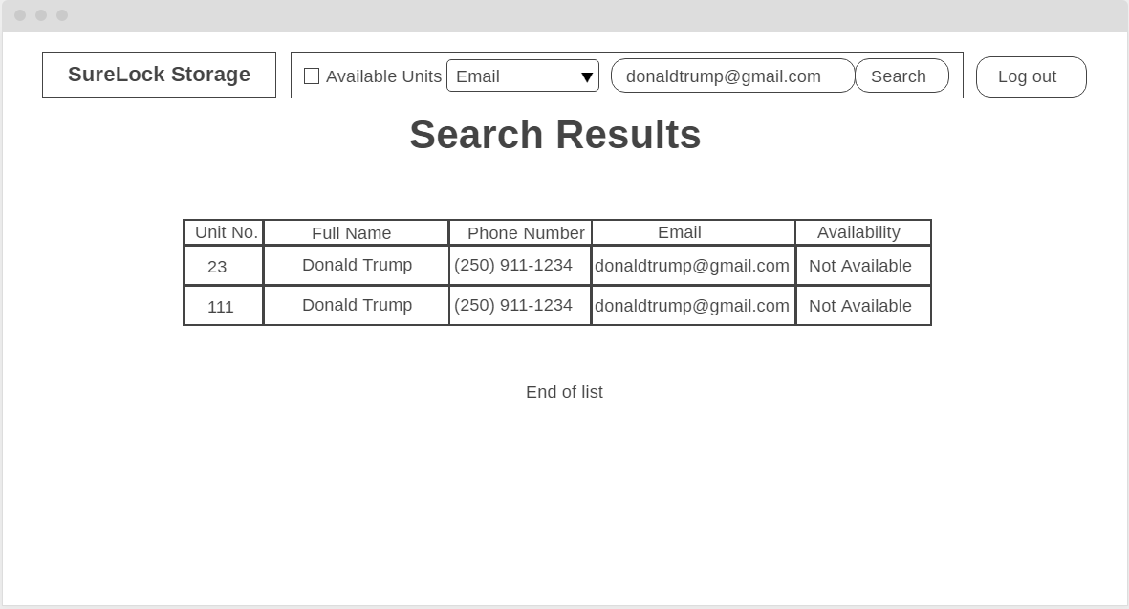Figure 18.8: UCSSF-01 Alternate 2b: UI Screen 3 – Search by Email Results Screen*

*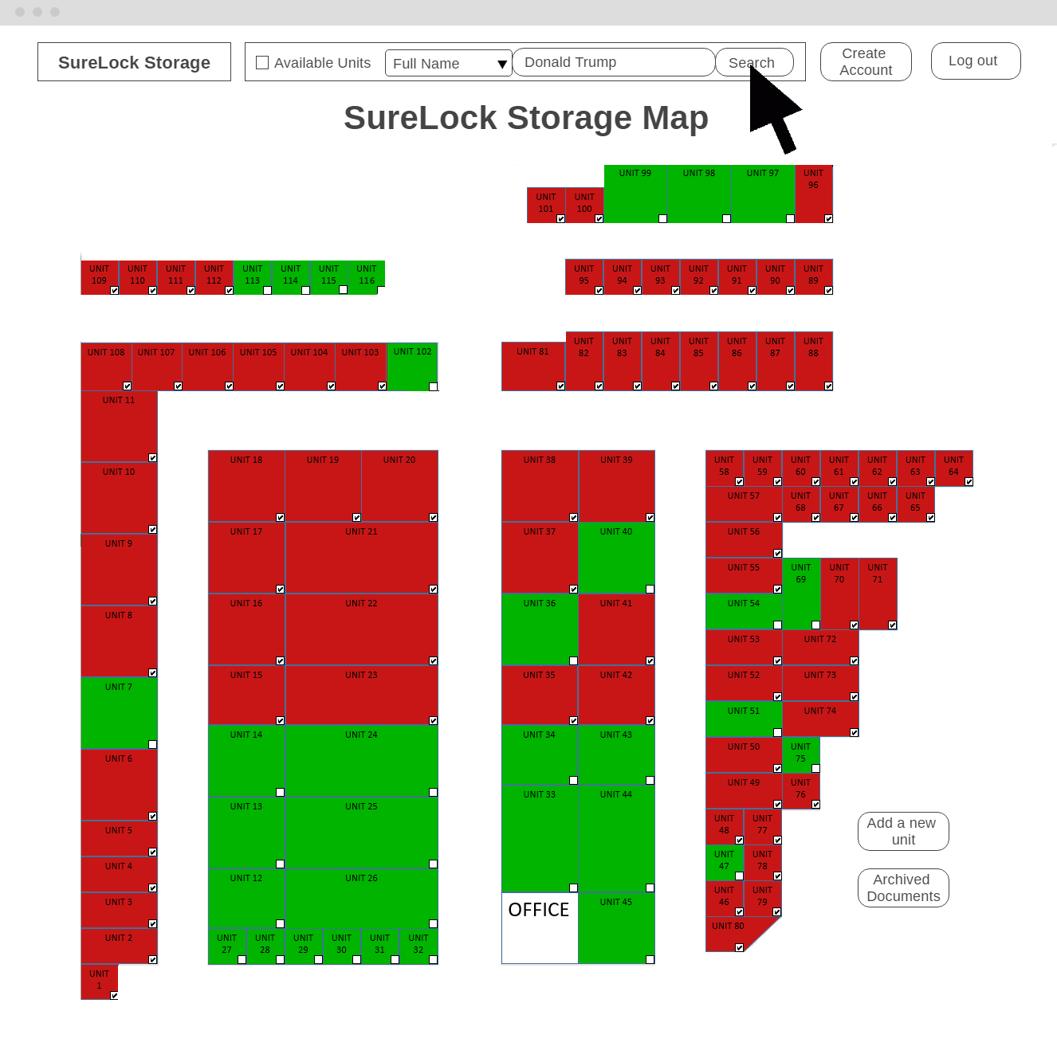Figure 18.9: UCSSF-01 UI Screen 3 – Search by Full Name Screen*

*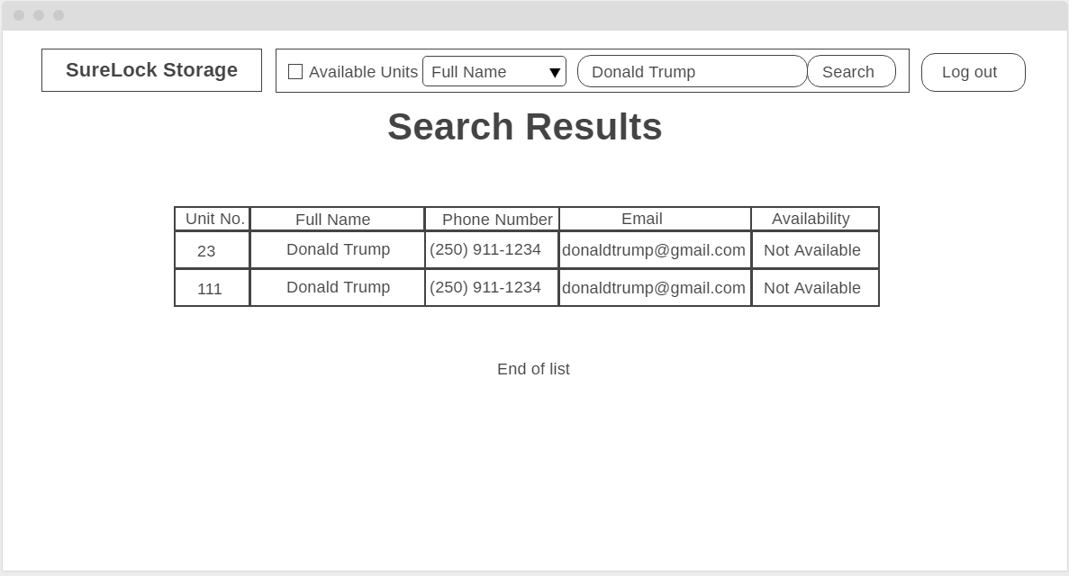Figure 18.10: UCSSF-01 UI Screen 4 – Search by Full Name Results Screen*

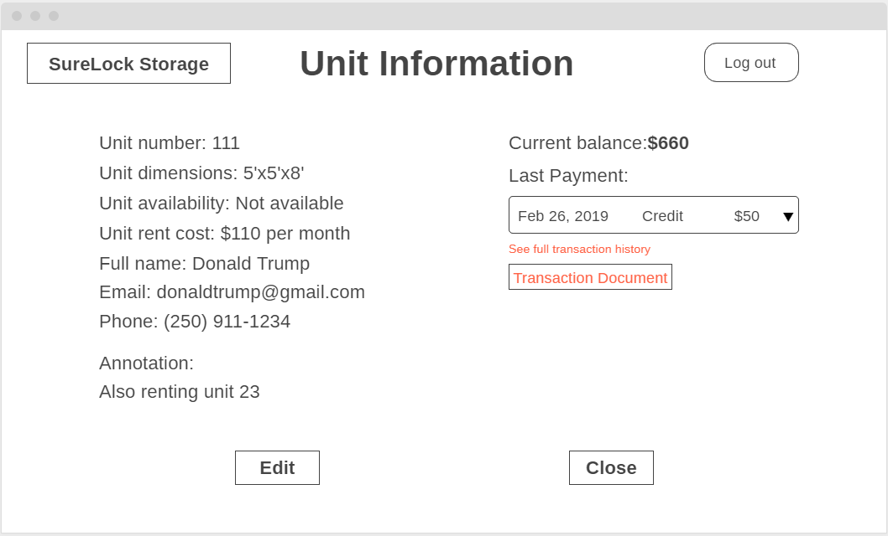

*Figure 18.11: UCSSF-01 UI Screen 5 – Unit Information Screen*

The user selects to search by full name and enters a client’s full name in the search bar on top of the facility map page. The system will display one or more units with the name entered in the search bar. The user selects the desired unit, which directs the user to the unit information page of the selected unit. The user may search the units by client’s phone number or email as well so long as the user has selected to search by phone number or email, respectively.

**Use Case UCSSF-02: Search by Unit Information**

Actors: Administrators and staff members

Precondition: The user has logged in under a valid account

Steps:

1. The user selects the searching feature
2. The user selects to search by unit number and enters a unit number
3. The system displays one or more units with the matching unit number
4. The user selects the desired unit and views the unit information

Success Condition: The desired unit information is displayed to the user

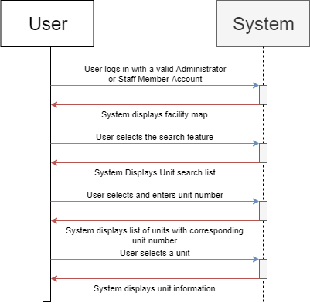

*Figure 19: UCSSF-02 Sequence Diagram*



*Figure 19.1: UCSSF-02 UI Screen 1 – Map Screen*

*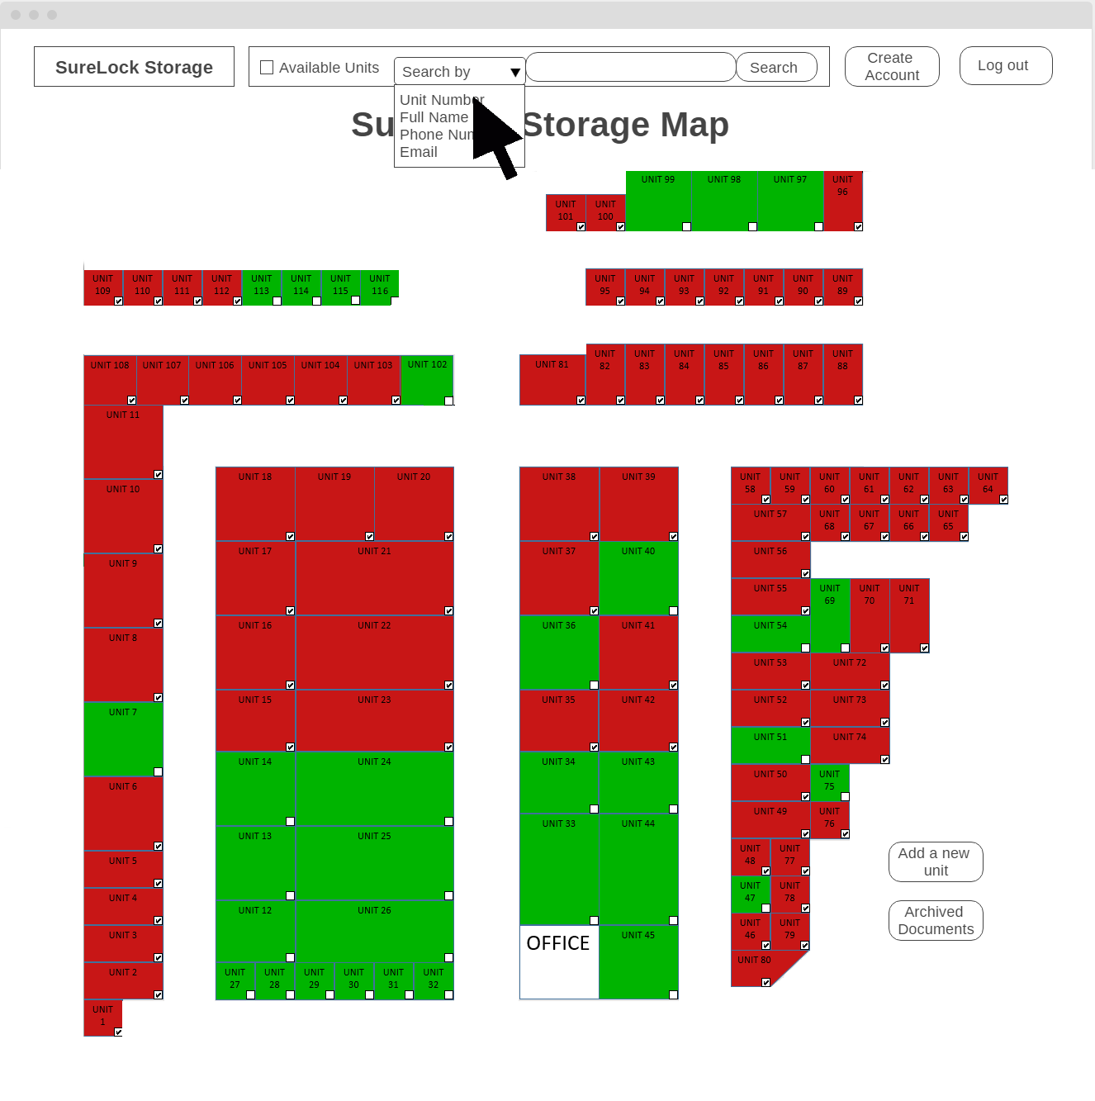Figure 19.2: UCSSF-02 UI Screen 2 – Search by Unit Number Screen*

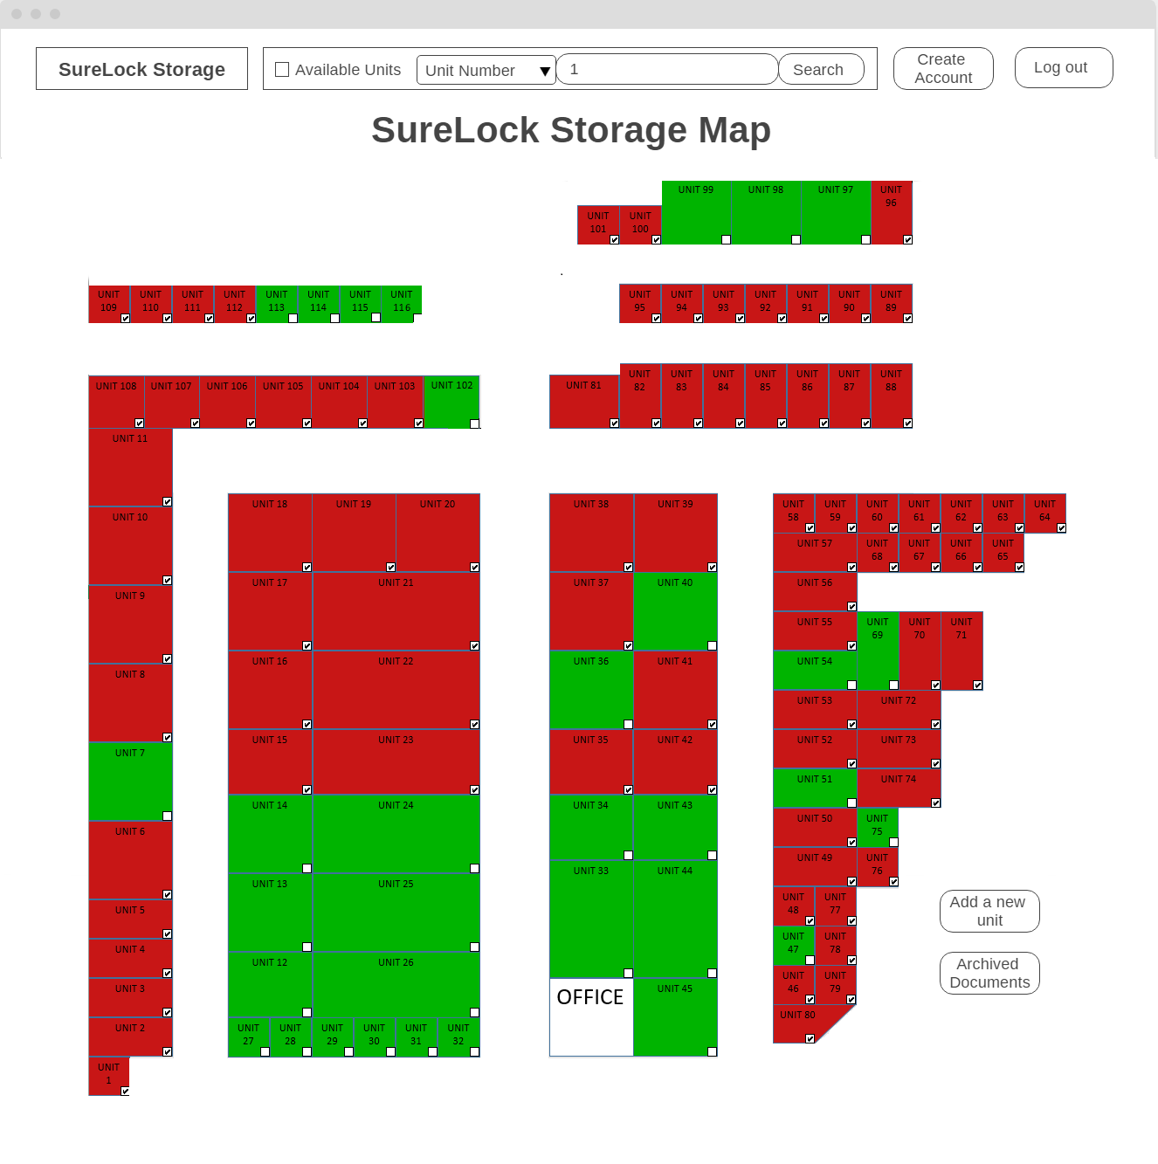

*Figure 19.3: UCSSF-02 UI Screen 3– Search by Unit Number Screen*

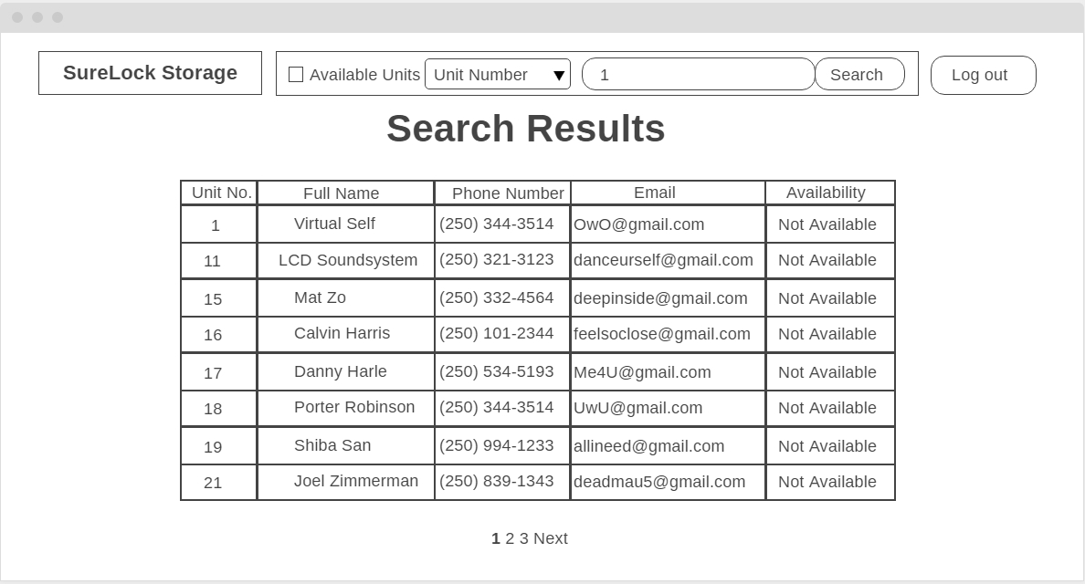

*Figure 19.4: UCSSF-02 UI Screen 4 – Search Results Screen*

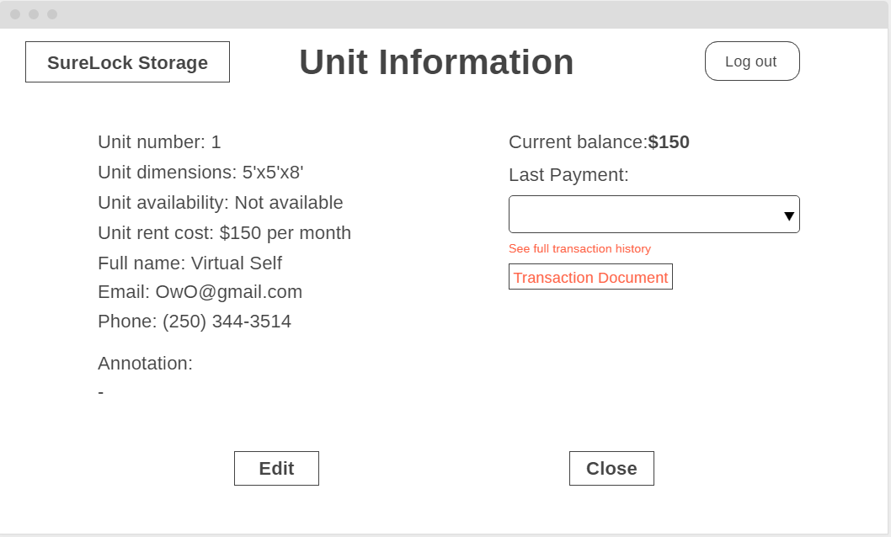

*Figure 19.5: UCSSF-02 UI Screen 3 – Unit Information Screen*

The user selects to search by unit number and enters the unit number in the search bar on top of the facility map page. The system then displays one or more units with that match the inputted number. The user can then select the unit from the list, and then they will be directed to the unit information page of the selected unit.

**Use Case UCSSF-03: Filter by Availability**

Actors: Administrators and staff members

Precondition: The user has logged in under a valid account

Steps:

1. The user selects the searching feature
2. The user sets the filter to available units only
3. The system displays a list of each available unit
4. The user selects the desired unit

Success Condition: The desired unit information is displayed to the user

Alternate Path: 2a) The user filters for not available units

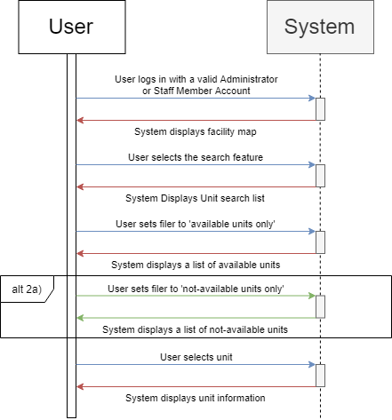

*Figure 20: UCSSF-03 Sequence Diagram*

*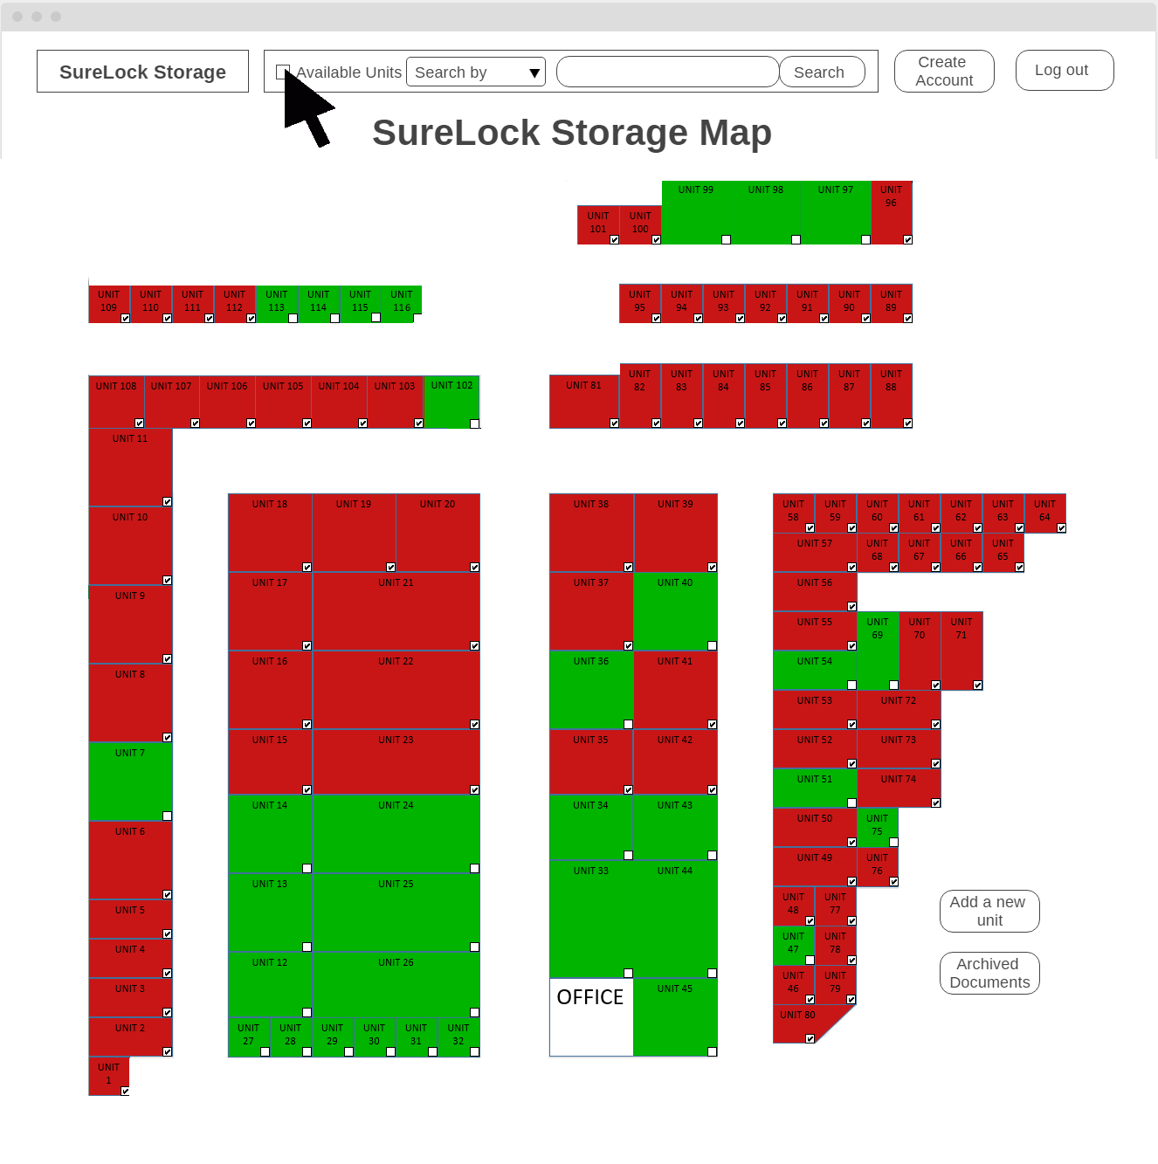Figure 20.1: UCSSF-03 UI Screen 1 – Available Units Search Screen*

*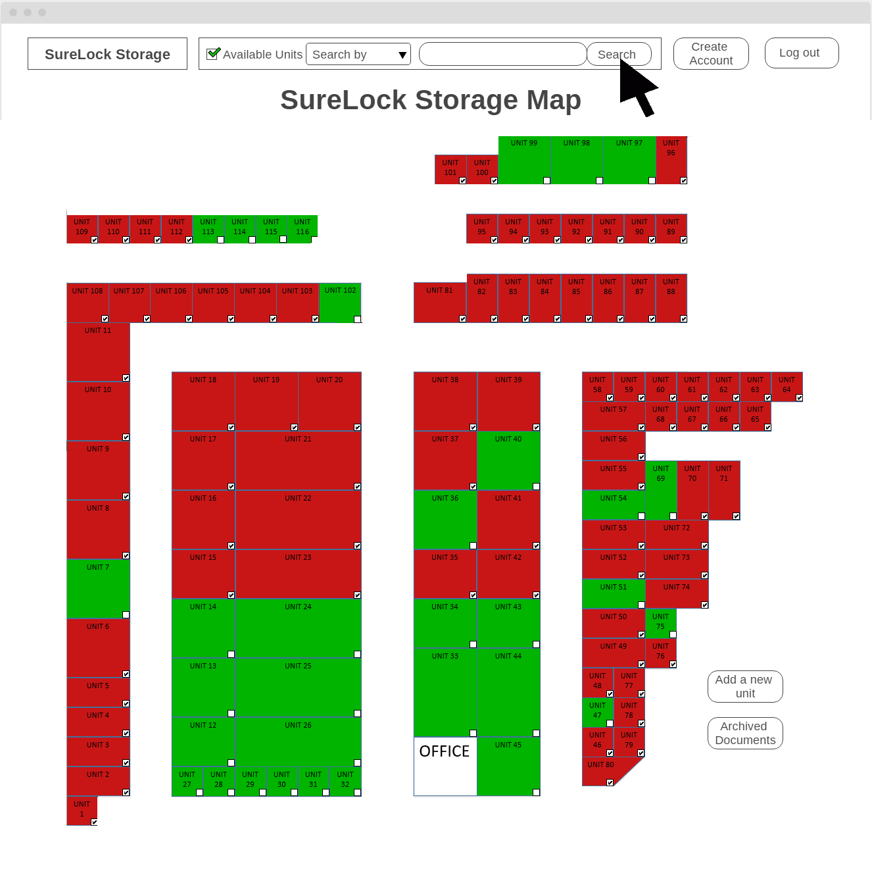Figure 20.2: UCSSF-03 UI Screen 2 – Available Units Checked Search Screen*

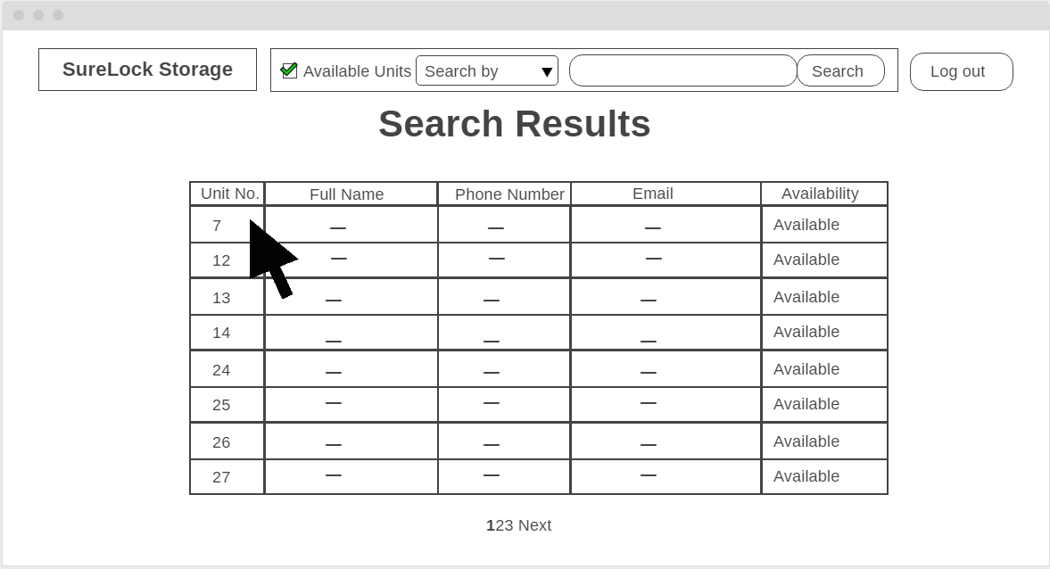

*Figure 20.3: UCSSF-03 UI Screen 3 – Available Units Search Screen*

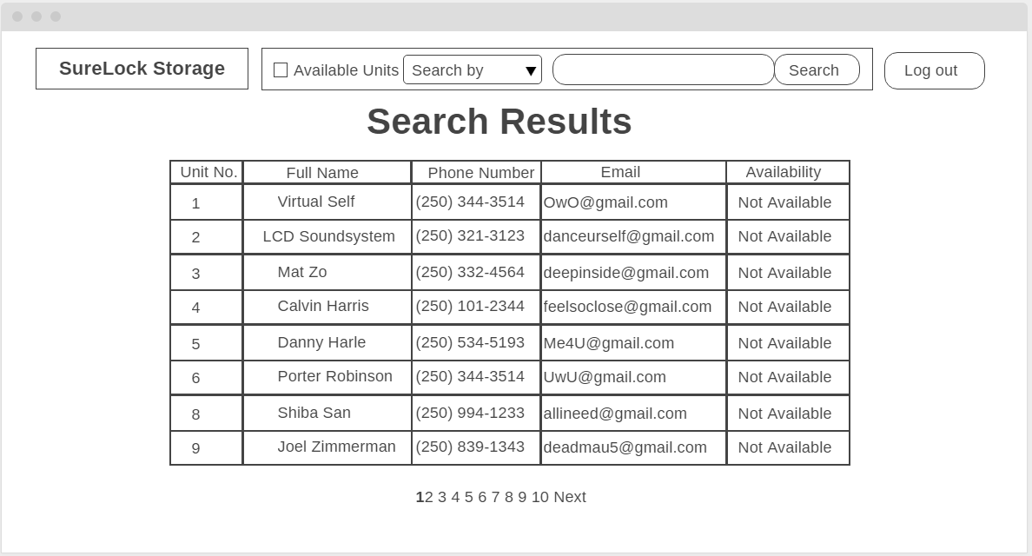

*Figure 20.4: UCSSF-03 Alternate 2a: UI Screen 1 – Unavailable Units Search Screen*

*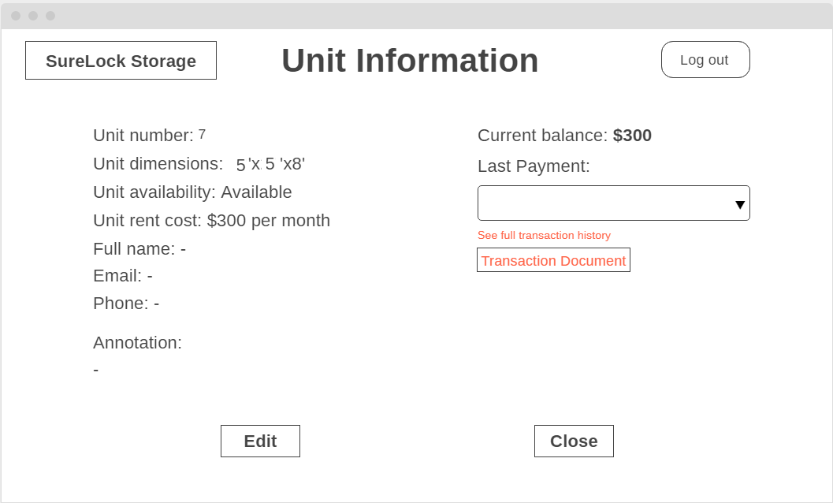Figure 20.5: UCSSF-03 UI Screen 4 – Available Units Info Screen*

The user clicks on the checkbox by the search bar. By clicking on the checkbox next to “Available Units”, the system displays the list of currently available units. For the alternate path, the system would the list of unavailable units if the user does not click on the checkbox.

**Use Case UCSSF-04: Search for Archived Transaction Documents**

Actors: Administrators

Precondition: The user has logged in under an Administrator account

Steps:

1. The user selects the Archived Documents search feature
2. The user enters the unit number associated with the desired transaction document
3. The system displays one or more transaction documents that match the inputted information

Success Condition: The desired transaction document is downloaded

Alternate Paths:

* 2a) The user enters a file name
* 2b) The user enters the full name of the client associated with the desired transaction document

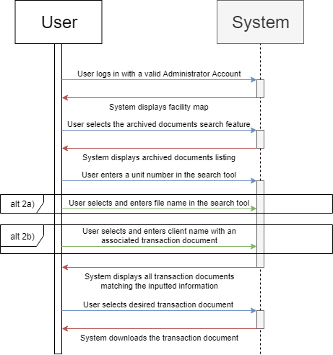

*Figure 21: UCSSF-04 Sequence Diagram*

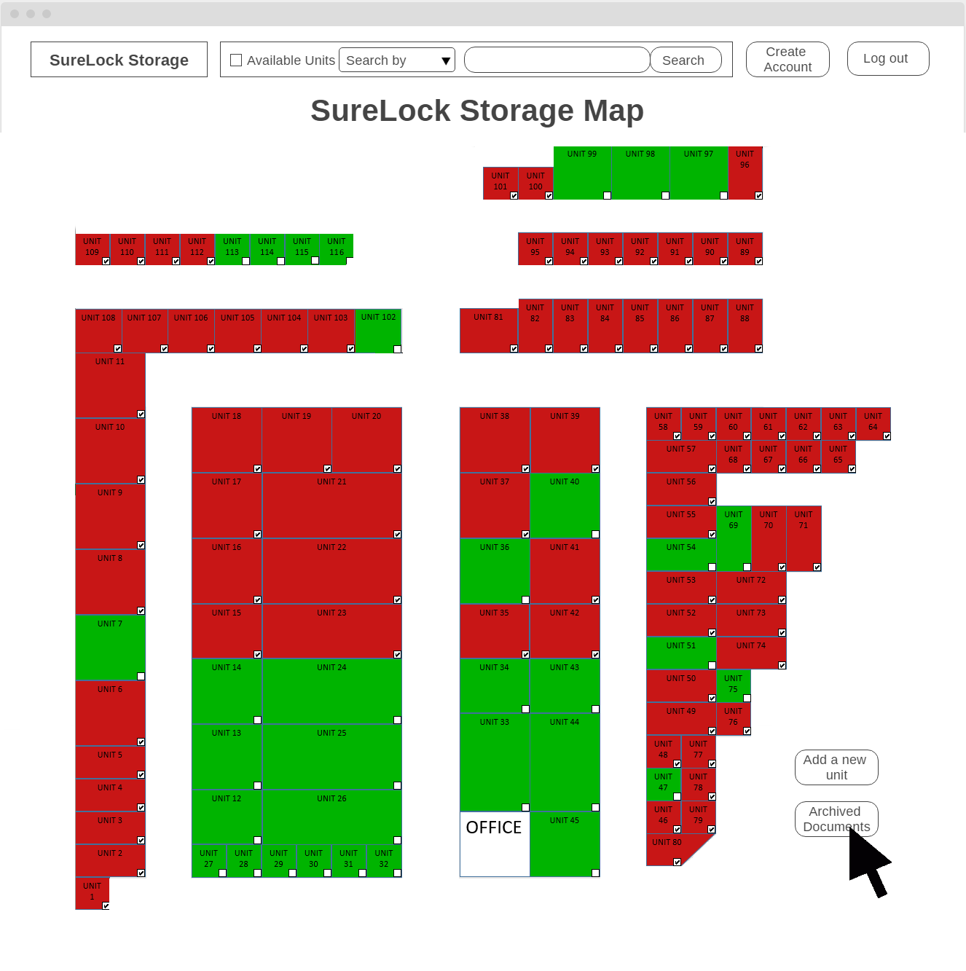

*Figure 21.1: UCSSF-04 UI Screen 1 – Map Screen*

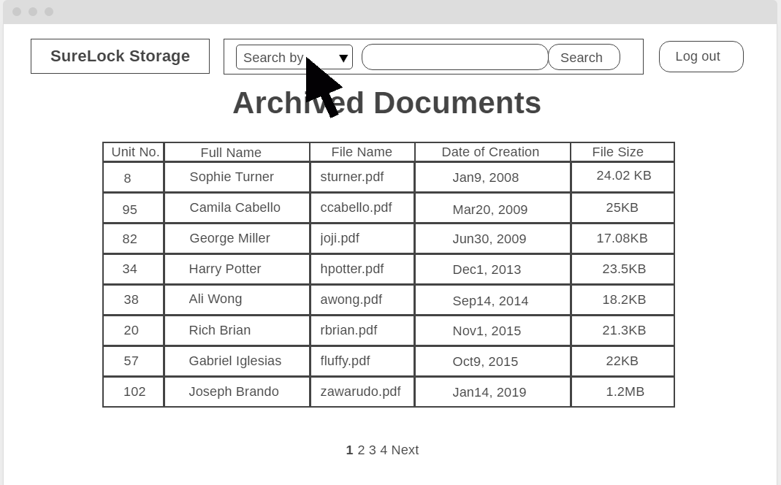

*Figure 21.2: UCSSF-04 UI Screen 2 – Archive Screen*

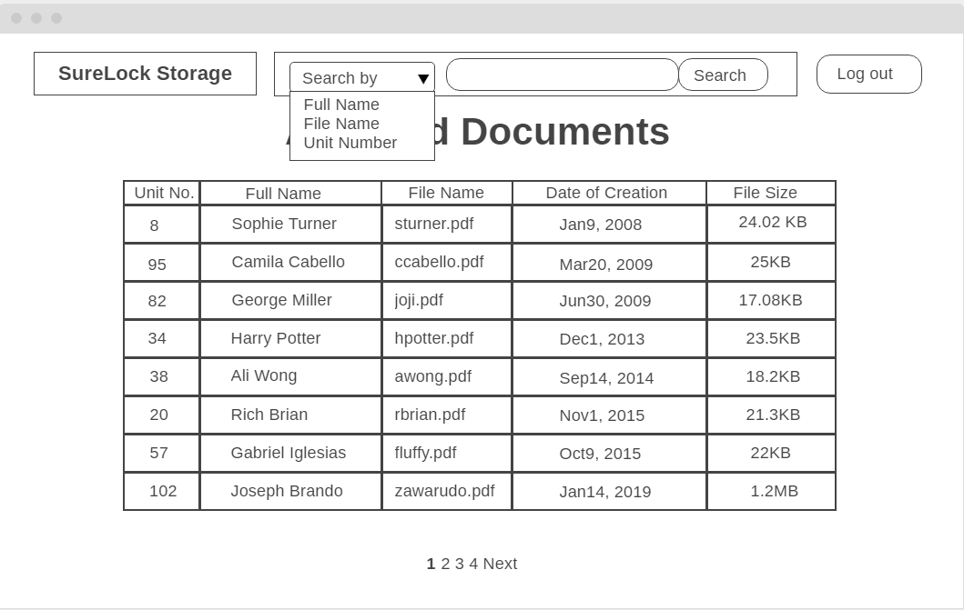

*Figure 21.3: UCSSF-04 UI Screen 3 – Archive Screen with Dropdown*

*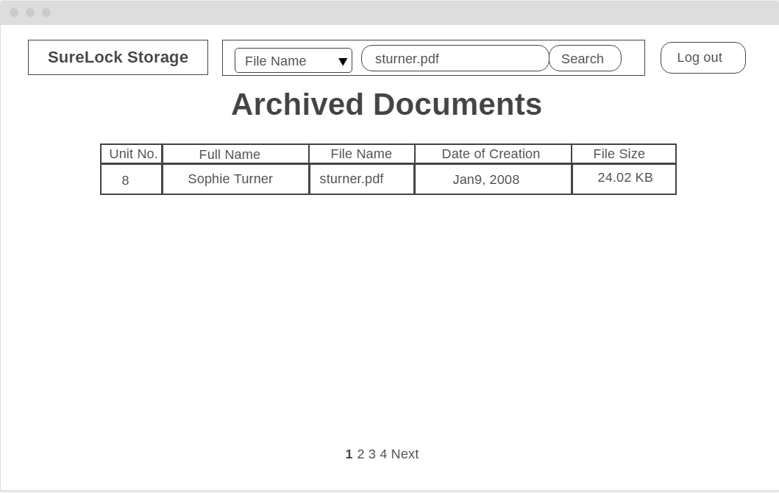Figure 21.4: UCSSF-04 Alternate 2a: UI Screen 1 – Archive Screen with Search Results*

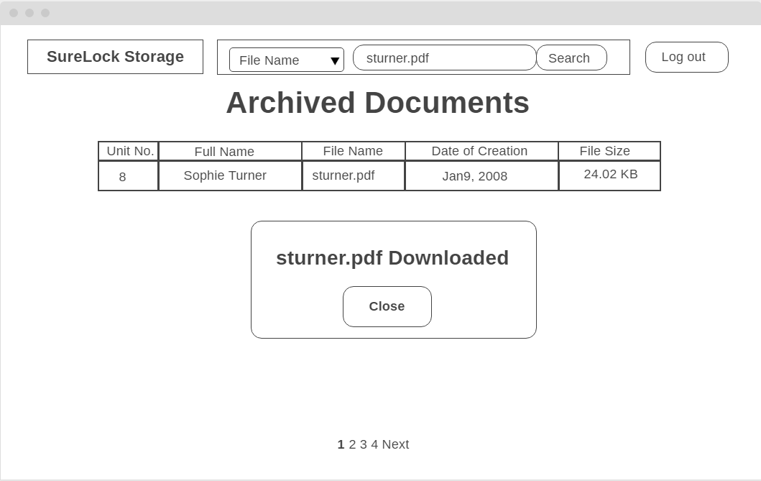

*Figure 21.5: UCSSF-04 Alternate 2a: UI Screen 2 – Archive Screen with File Name Search Name Results Downloaded*

*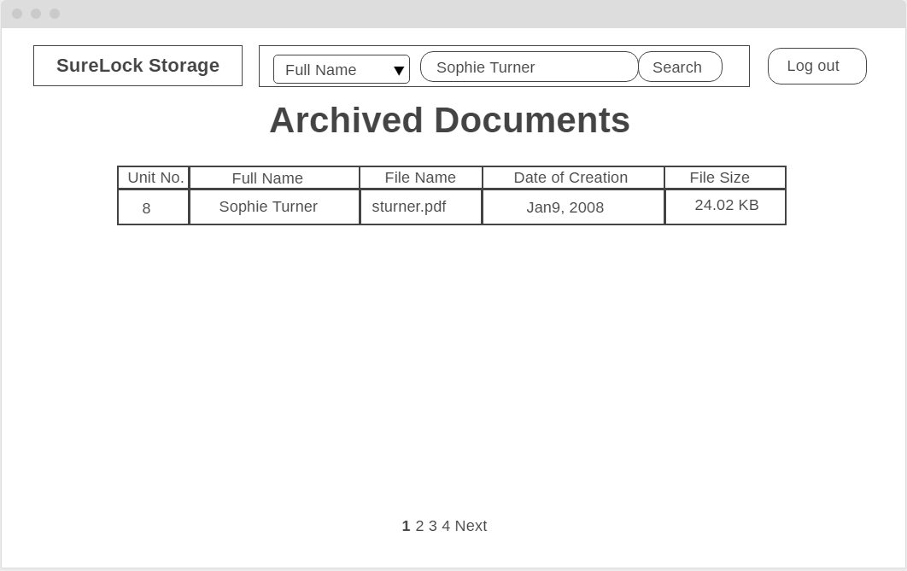Figure 21.6: UCSSF-04 UI Alternate 2b: UI Screen 1 – Archive Screen with Search Results*

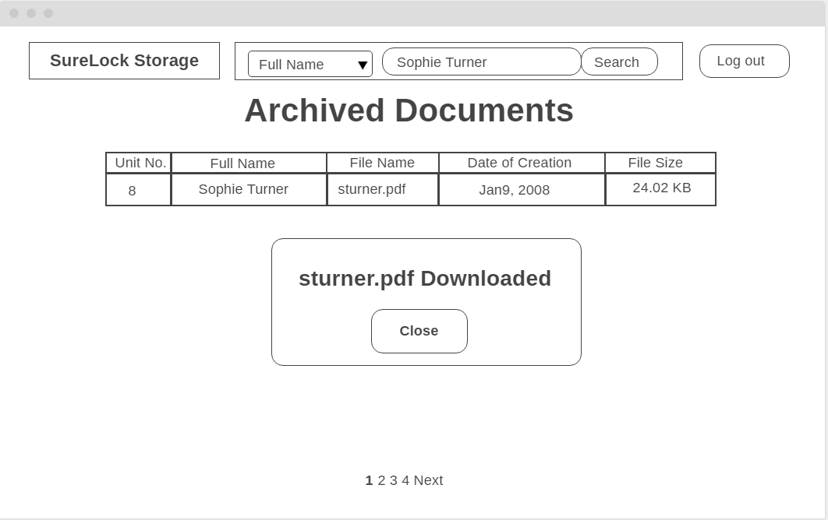

*Figure 21.7: UCSSF-04 Alternate 2b: UI Screen 2 – Archive Screen with Full Name Search Name Results Downloaded*

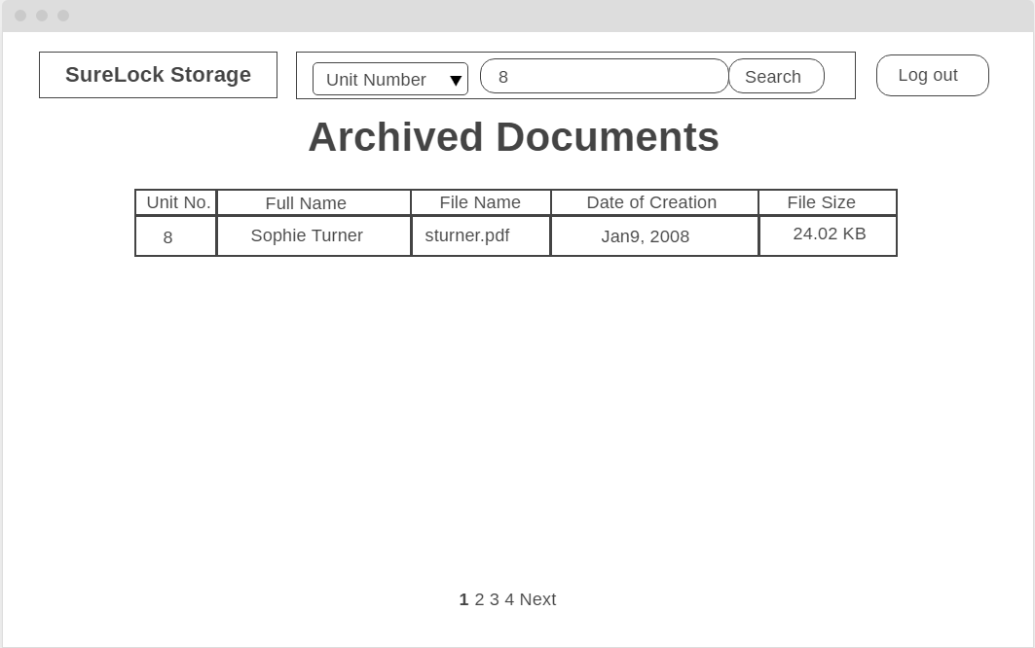

*Figure 21.8: UCSSF-04 UI Screen 4 – Archive Screen with Search Results by Unit Number*

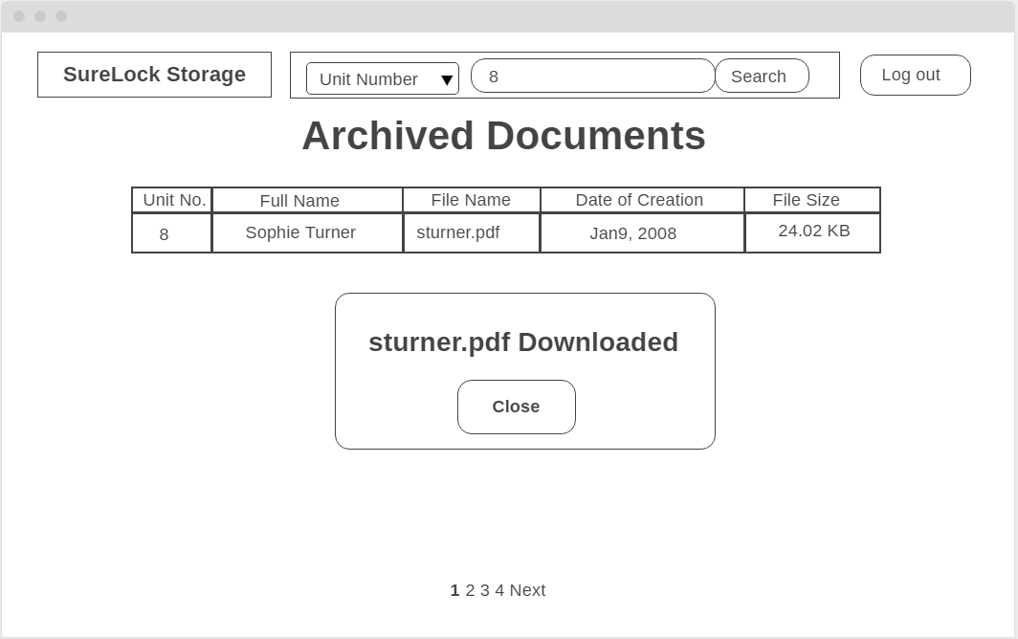

*Figure 21.9: UCSSF-04 UI Screen 5 – Archive Screen with Search Results by Unit Number Downloaded*

The user clicks on the “Archived Documents” button on the facility map page. The user is directed to the Archived Documents page where they can enter a unit number, a file name, or the full name of the client associated with the transaction document in the search bar on the top of the page. The system displays a list of one or more transaction documents that match the entered unit number.

## 7.4 Use Case Model

## https://cdn.discordapp.com/attachments/555220207749169187/555220810147823616/Use_Case_Model_attempt_2.png

*Figure 22: Use Case Model*